Load Test Report

## Load Details

Stack: S4

Stack Url: https://mercury.uptycs.net/

Sprint: 139

Build: 139005

Load Name: AWS_multicustomer

Load Duration In Hrs: 12 hrs

Load Start Time Ist: 2023-08-24 00:33

Load End Time Ist: 2023-08-24 12:33

### Test Environment details

|  |  |  |  |  |
| --- | --- | --- | --- | --- |
| node | cluster | cores | ram | storage |
| s4c1pn1 | 1 | 32 | 188 | root_partition:731G, kafka:3.6T, |
| s4c1pn2 | 1 | 32 | 188 | root_partition:365G, kafka:3.6T, |
| s4c1pn3 | 1 | 32 | 188 | root_partition:365G, kafka:3.6T, |
| s4c1pn4 | 1 | 32 | 188 | root_partition:365G, kafka:3.6T, |
| s4c1pn5 | 1 | 32 | 188 | root_partition:365G, kafka:3.6T, |
| s4c1pn6 | 1 | 32 | 188 | root_partition:365G, kafka:3.6T, |
| s4c2pn1 | 2 | 32 | 188 | root_partition:731G, kafka:3.6T, |
| s4c2pn2 | 2 | 32 | 188 | root_partition:365G, kafka:3.6T, |
| s4c2pn3 | 2 | 32 | 188 | root_partition:731G, kafka:3.6T, |
| s4c2pn4 | 2 | 32 | 188 | root_partition:365G, kafka:3.6T, |
| s4c2pn5 | 2 | 32 | 188 | root_partition:3.6T, kafka:366G, |
| s4c2pn6 | 2 | 32 | 188 | root_partition:365G, kafka:3.6T, |
| s4c1dn1 | 1 | 32 | 251 | root_partition:731G, spark:3.6T, dn1:3.6T, dn2:3.6T, dn3:3.6T, |
| s4c1dn2 | 1 | 32 | 251 | root_partition:731G, spark:3.6T, dn1:3.6T, dn2:3.6T, dn3:3.6T, |
| s4c1dn3 | 1 | 32 | 251 | root_partition:731G, spark:3.6T, dn1:3.6T, dn2:3.6T, dn3:3.6T, |
| s4c1dn4 | 1 | 32 | 251 | root_partition:731G, spark:3.6T, dn1:3.6T, dn2:3.6T, dn3:3.6T, |
| s4c1dn5 | 1 | 32 | 251 | root_partition:731G, spark:3.6T, dn1:3.6T, dn2:3.6T, dn3:3.6T, |
| s4c1dn6 | 1 | 32 | 251 | root_partition:731G, spark:3.6T, dn1:3.6T, dn2:3.6T, dn3:3.6T, |
| s4c2dn1 | 2 | 32 | 251 | root_partition:731G, spark:3.6T, dn1:3.6T, dn2:3.6T, dn3:3.6T, |
| s4c2dn2 | 2 | 32 | 251 | root_partition:731G, spark:3.6T, dn1:3.6T, dn2:3.6T, dn3:3.6T, |
| s4c2dn3 | 2 | 32 | 251 | root_partition:731G, spark:3.6T, dn1:3.6T, dn2:3.6T, dn3:3.6T, |
| s4c2dn4 | 2 | 32 | 251 | root_partition:731G, spark:3.6T, dn1:3.6T, dn2:3.6T, dn3:3.6T, |
| s4c2dn5 | 2 | 32 | 251 | root_partition:731G, spark:3.6T, dn1:3.6T, dn2:3.6T, dn3:3.6T, |
| s4c2dn6 | 2 | 32 | 251 | root_partition:731G, spark:3.6T, dn1:3.6T, dn2:3.6T, dn3:3.6T, |
| s4configdb1 | 1 | 32 | 188 | root_partition:731G, pg:3.6T, data:3.6T, |
| s4configdb2 | 1 | 32 | 188 | root_partition:731G, pg:3.6T, data:3.6T, |
| s4mon | 1 | 16 | 78 | root_partition:196G, data:3.6T, |

## Disk Usages

### KAFKA disk space usage

|  |  |  |  |  |
| --- | --- | --- | --- | --- |
| Node | KAFKA total space configured(TB) | KAFKA disk used % before load | KAFKA disk used % after load | KAFKA used space during load (GB) |
| s4c1pn1v | 3.6 | 1.0 | 3.0 | 73.73 |
| s4c1pn2v | 3.6 | 1.0 | 3.0 | 73.73 |
| s4c1pn3v | 3.6 | 1.0 | 3.0 | 73.73 |
| s4c1pn4v | 3.6 | 1.0 | 3.0 | 73.73 |
| s4c1pn5v | 3.6 | 1.0 | 3.0 | 73.73 |
| s4c1pn6v | 3.6 | 1.0 | 3.0 | 73.73 |
| s4c2pn1v | 3.6 | 1.0 | 3.0 | 73.73 |
| s4c2pn2v | 3.6 | 1.0 | 3.0 | 73.73 |
| s4c2pn3v | 3.6 | 1.0 | 3.0 | 73.73 |
| s4c2pn4v | 3.6 | 1.0 | 3.0 | 73.73 |
| s4c2pn5v | 0.37 | 1.0 | 25.0 | 89.95 |
| s4c2pn6v | 3.6 | 1.0 | 3.0 | 73.73 |

### HDFS disk space usage

|  |  |  |  |  |
| --- | --- | --- | --- | --- |
| Node | HDFS total space configured(TB) | HDFS disk used % before load | HDFS disk used % after load | HDFS used space during load (GB) |
| s4c1dn6 | 11.78 | 29.59 | 29.82 | 27.39 |
| s4c1dn4 | 11.78 | 28.99 | 29.22 | 26.79 |
| s4c1dn3 | 11.81 | 29.06 | 29.26 | 23.67 |
| s4c1dn5 | 11.78 | 28.16 | 28.37 | 24.95 |
| s4c2dn4 | 11.78 | 26.67 | 26.88 | 26.03 |
| s4c2dn2 | 11.78 | 26.65 | 26.88 | 26.96 |
| s4c2dn6 | 11.78 | 26.26 | 26.49 | 27.33 |
| s4c2dn5 | 11.78 | 26.19 | 26.39 | 23.85 |
| s4c2dn3 | 11.78 | 25.98 | 26.21 | 27.36 |
| s4c1dn2 | 11.81 | 26.11 | 26.32 | 25.88 |
| s4c2dn1 | 11.78 | 25.28 | 25.48 | 24.01 |
| s4c1dn1 | 11.81 | 24.68 | 24.87 | 22.43 |

### PG disk space usage

|  |  |  |
| --- | --- | --- |
| partition | master configdb node | standby configdb node |
| /pg | 18G | 26G |
| /data | 55G | 67G |

### Kafka topics

|  |
| --- |
| 139005 |
| Summary : No new topics added |
| New Topics : |
| Old Topics : __consumer_offsets __debezium-heartbeat.cdc __debezium-heartbeat.statedb agentghquery agentkubequery agentlesslog agentlesslogdecorator agentoktaquery agentosquery alert alert_replay api asset-capability assetgroup1 audit auto-exception az_events_blob bulk_replay cdc.public.alerts cdc.public.asset_cloud_infos cdc.public.asset_tags cdc.public.assets cdc.public.cloud_accounts cdc.public.customer_database cdc.public.customers cdc.public.incidents cdc.public.object_groups cdc.public.user_object_groups cdc.public.users cloudconnectorsink cloudqueryVuln cloudqueryevents cloudqueryinventory cloudtrail_objects compliance compliance_summary containers cqazevents cqcloudtrail cqcloudtrail_data_sink cqcloudtrail_ro_sink debezium_configs debezium_offsets debezium_statedb_configs debezium_statedb_offsets debezium_statedb_status_storage debezium_status_storage decorators detection ephermalresources epsink event event_cloud event_replay gcp_cloudlog_objects managedavtables notifications op osquery_cli_tags prestoquerylogs querypack realtimequery registryevent reportschedule1 scan_summary sidequerydecorator slackuser1 state statedb.public.containers_current statedb.public.kubernetes_nodes_current statedb.public.kubernetes_pods_containers_current statedb.public.kubernetes_pods_current statedb.public.vulnerabilities_scanned_images tag1 threat_indicators unified_dashboard uptycs-cloud-remediation vulnerabilities vulntickets |

## Charts

### Cpu consumed by memgraphdb

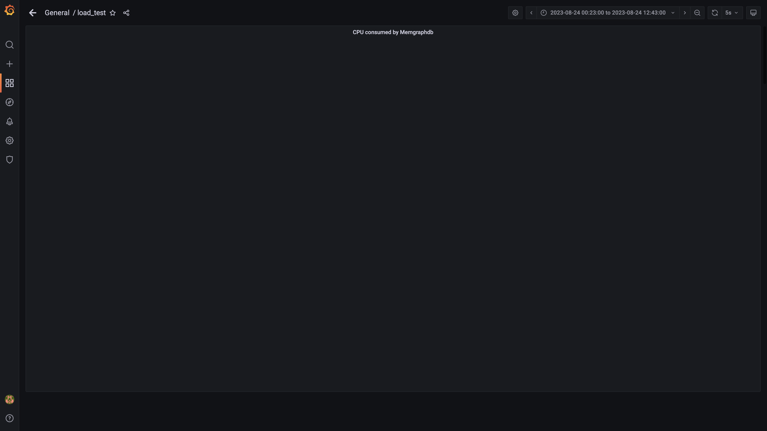

### Cpu consumed by effective permissions

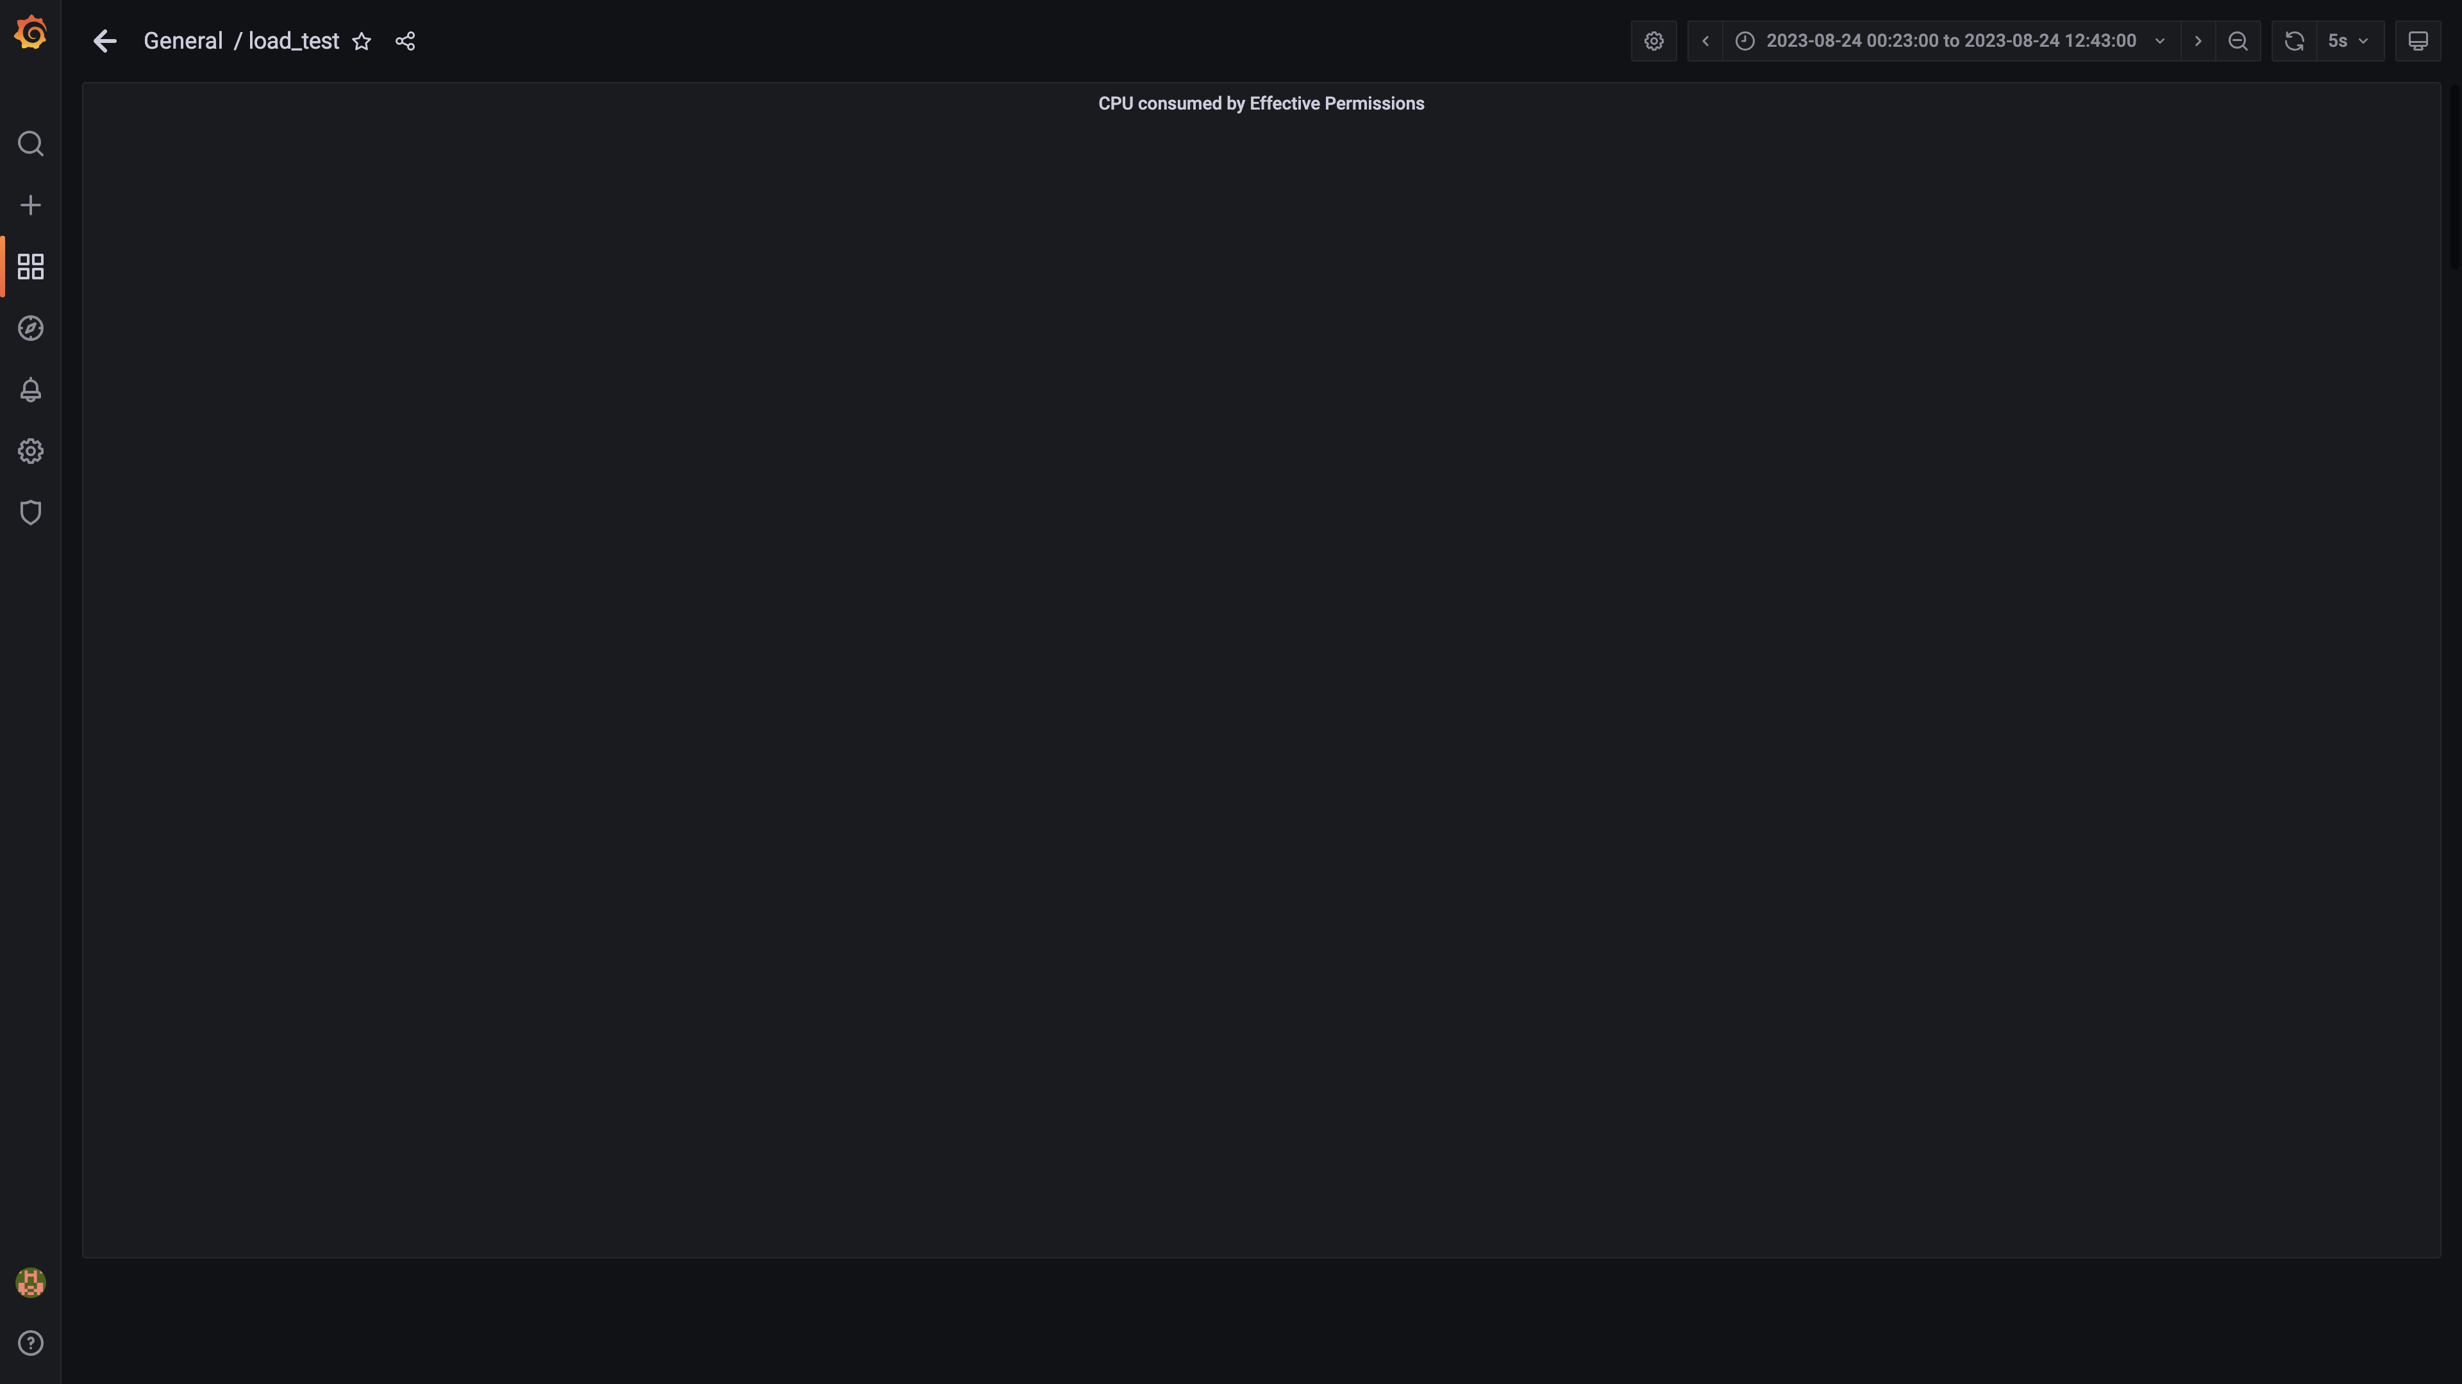

### Cpu consumed by stsdetection

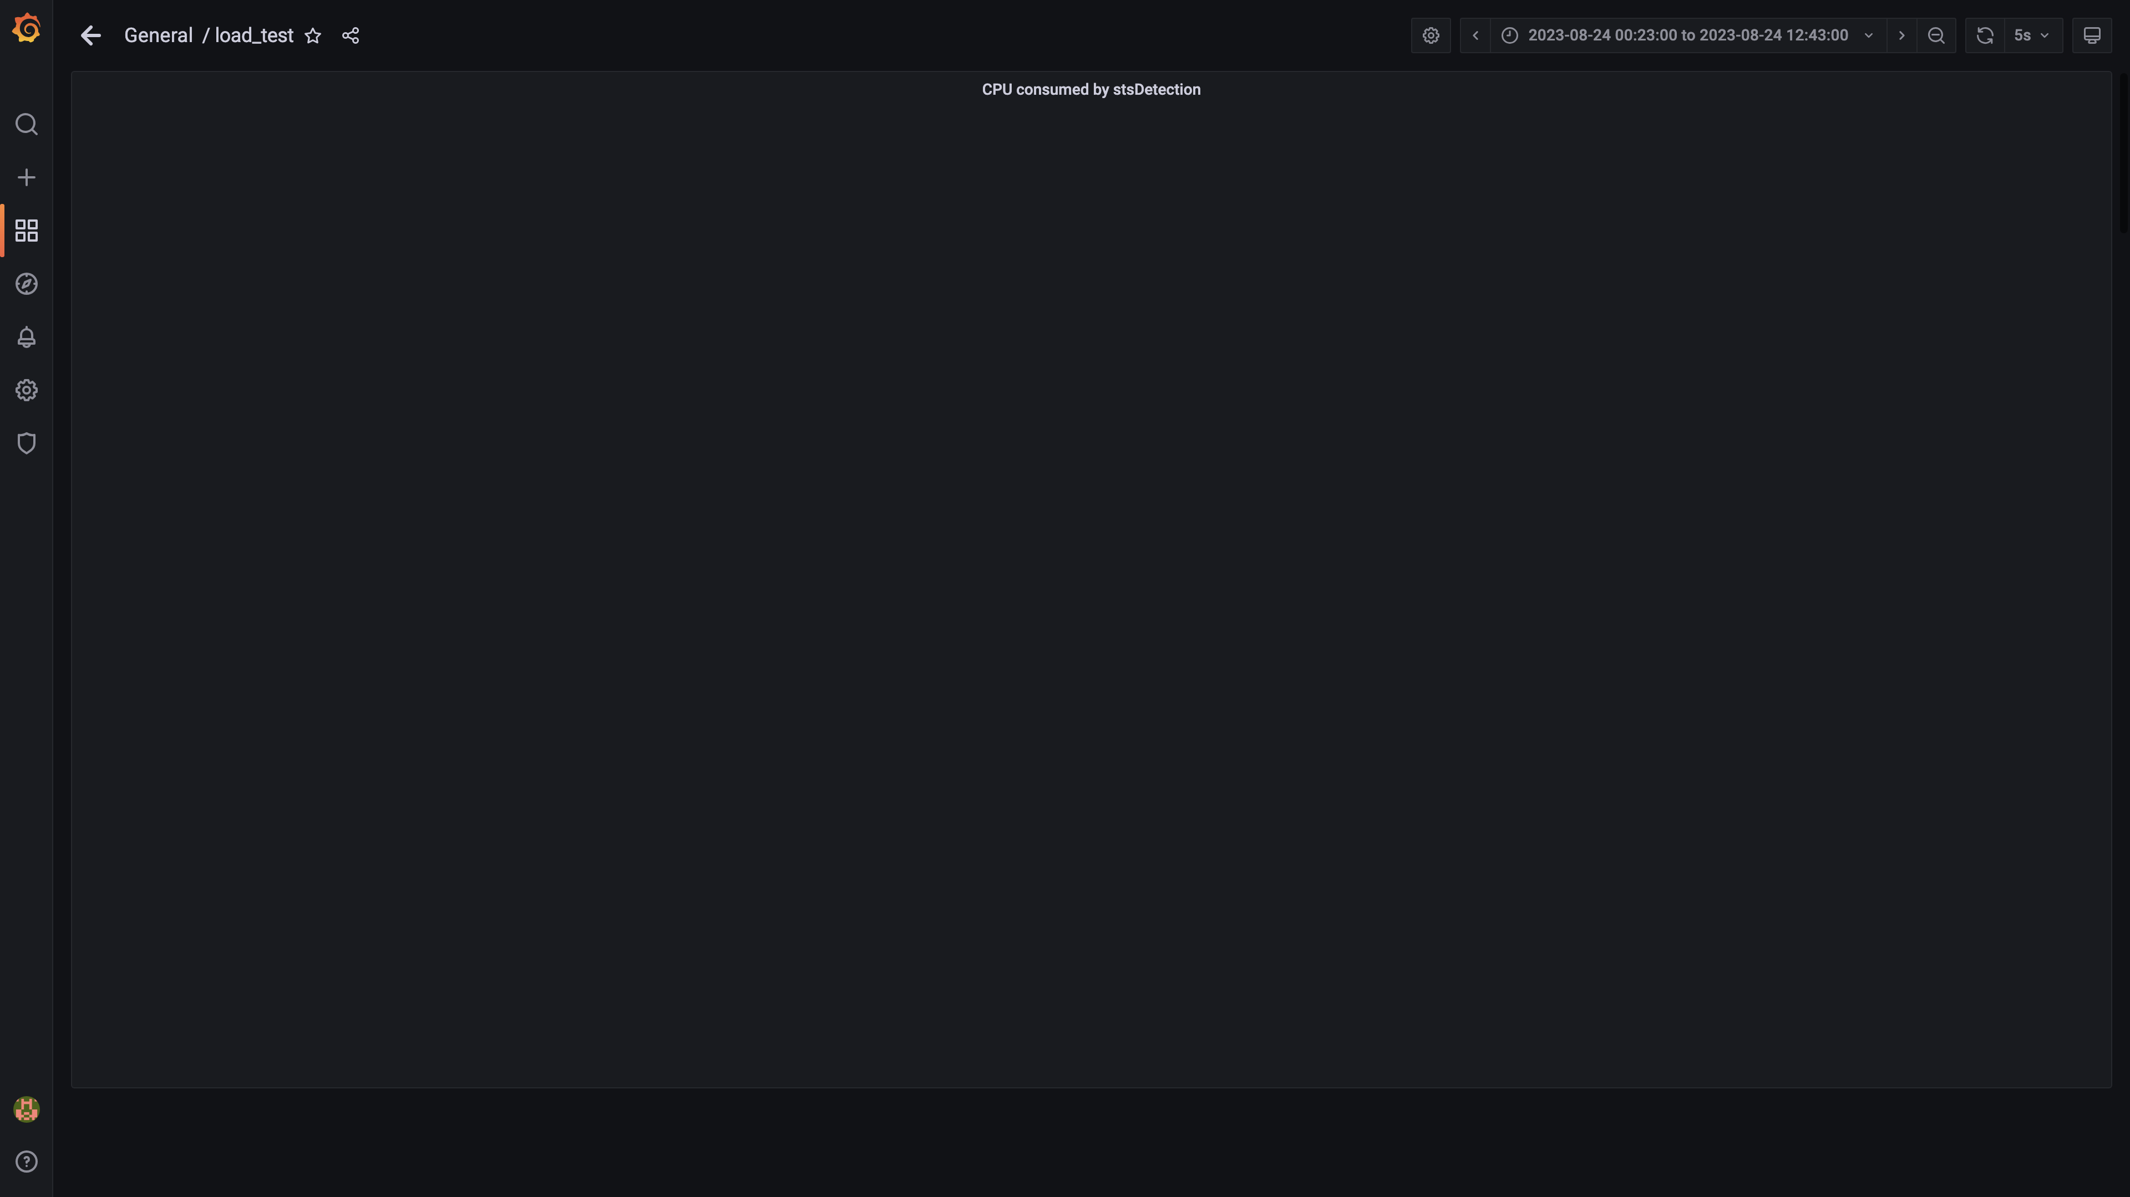

### Data node cpu busy percent

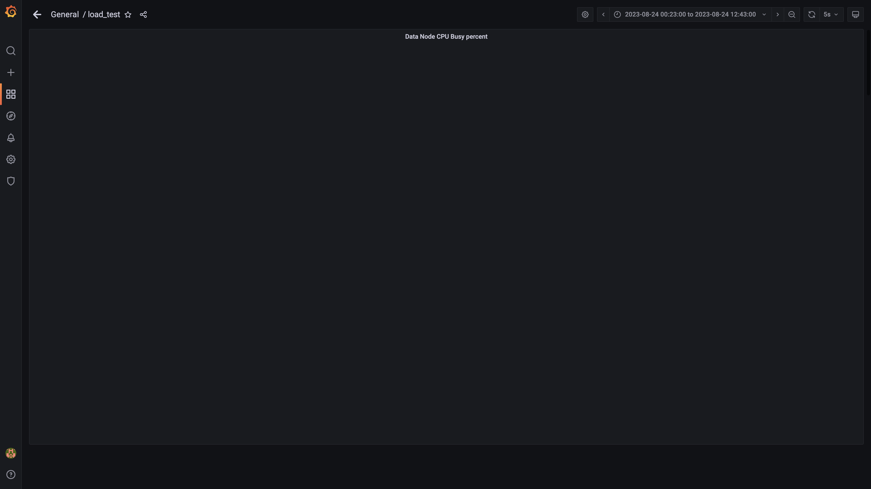

### Process node cpu busy percent

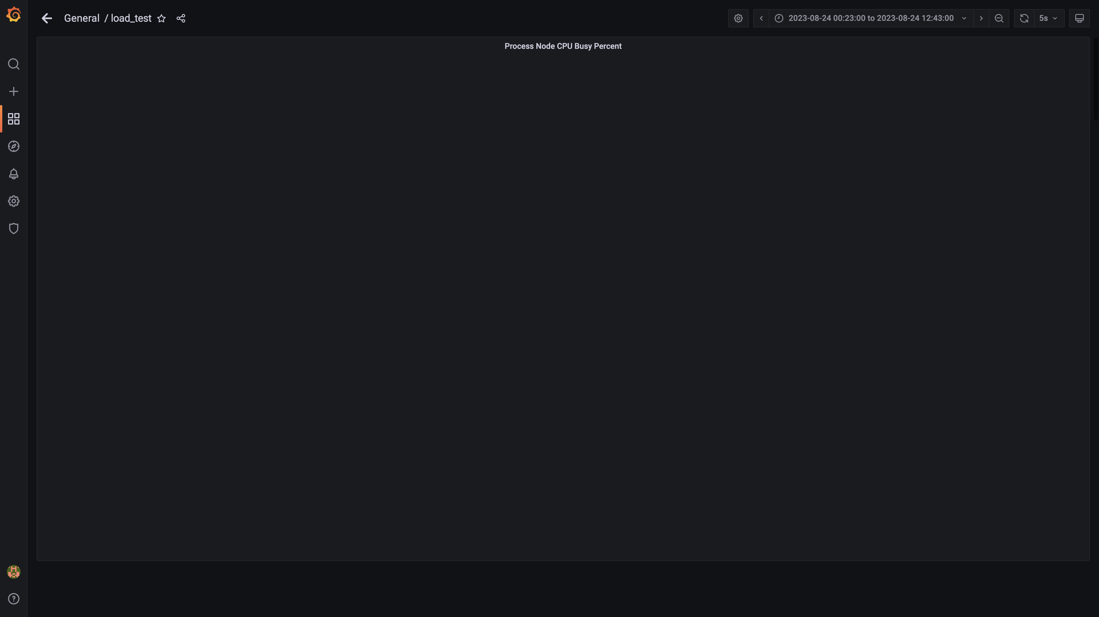

### Sts app cpu%

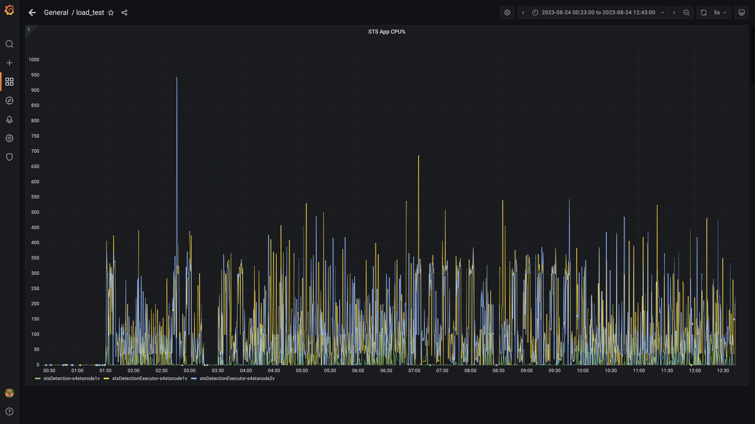

### Postgres node cpu busy percent

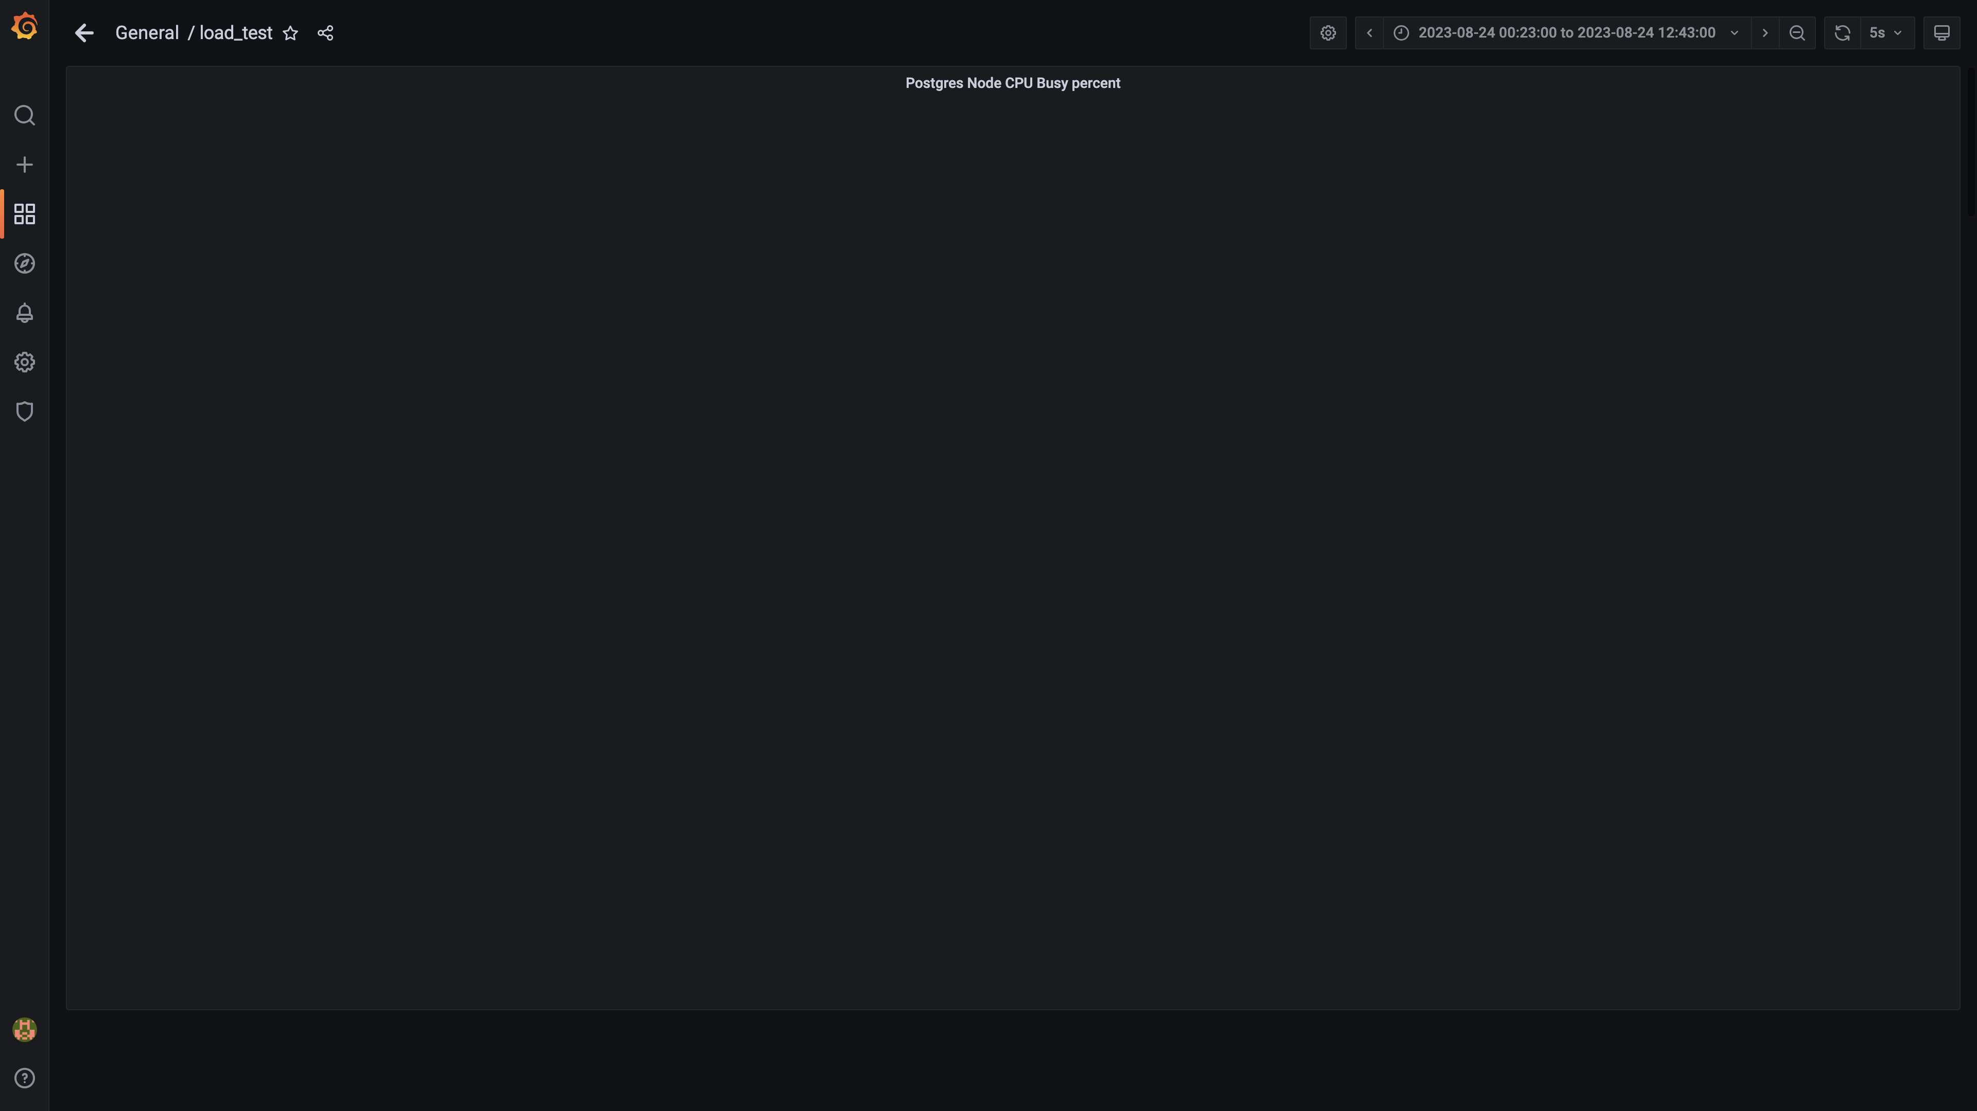

### Cpu consumed by cloudqueryconsumer

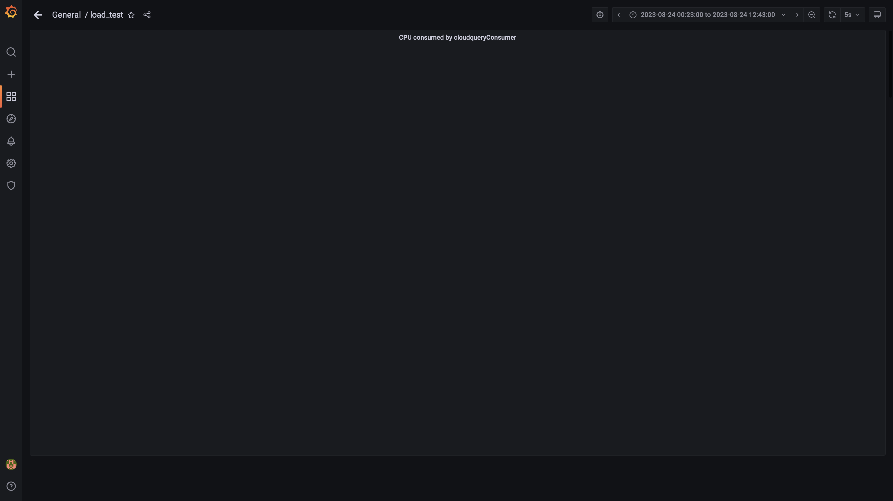

### Cpu consumed by clouddetectionconsumer

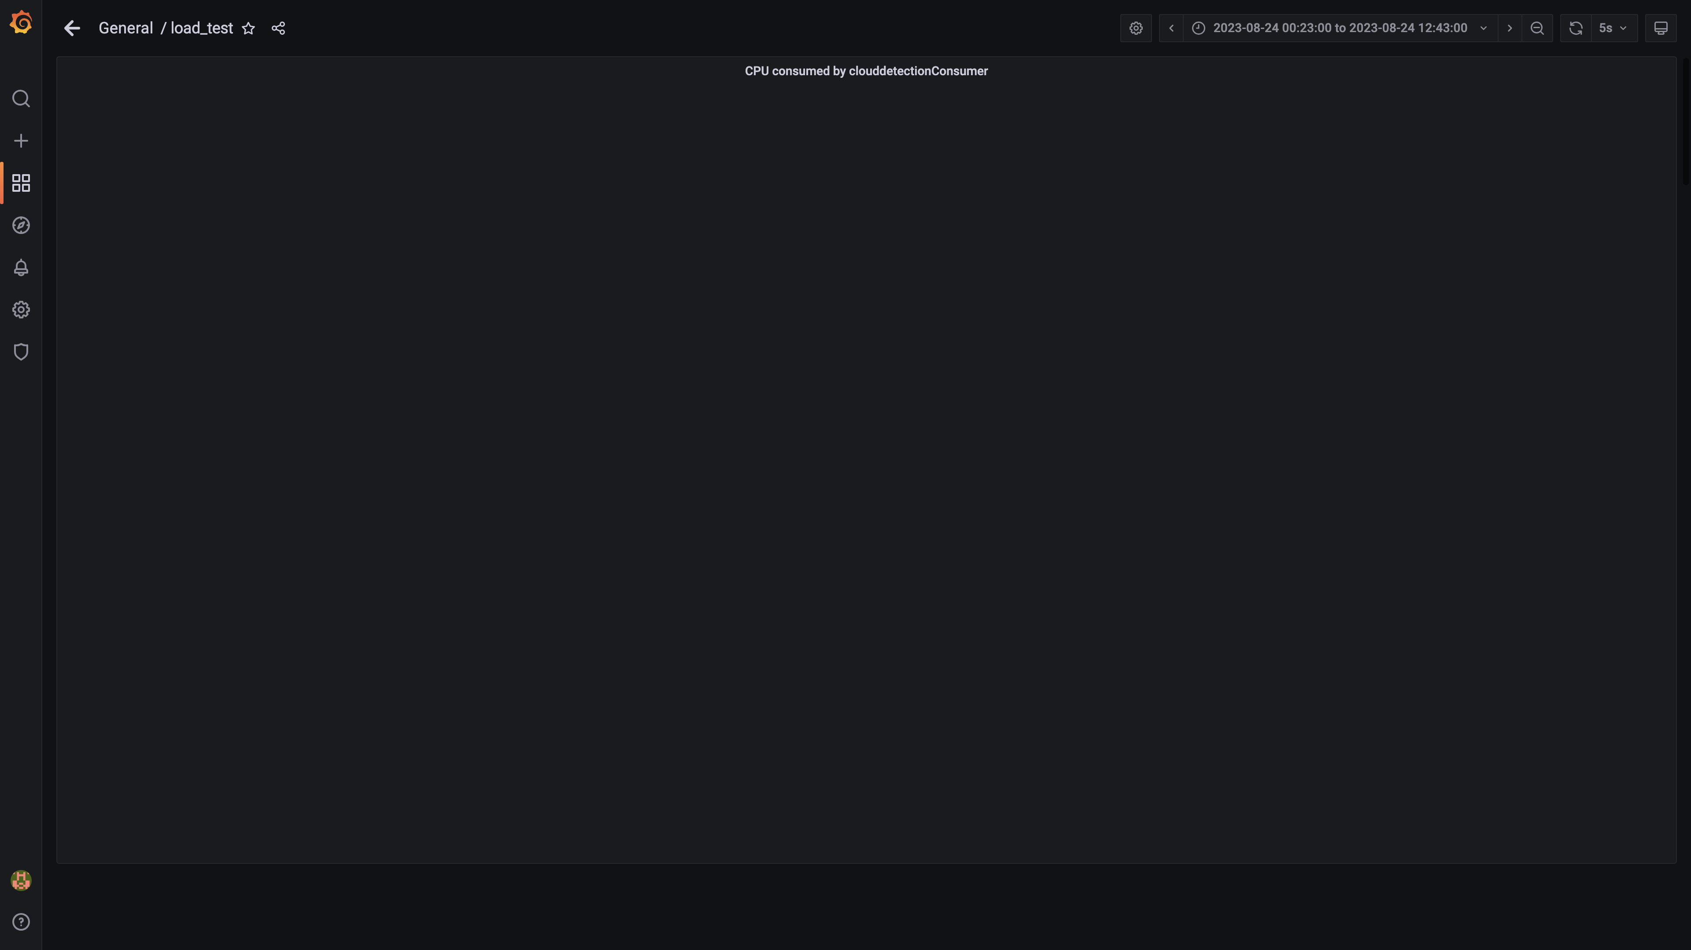

### Statedb cpu used percent

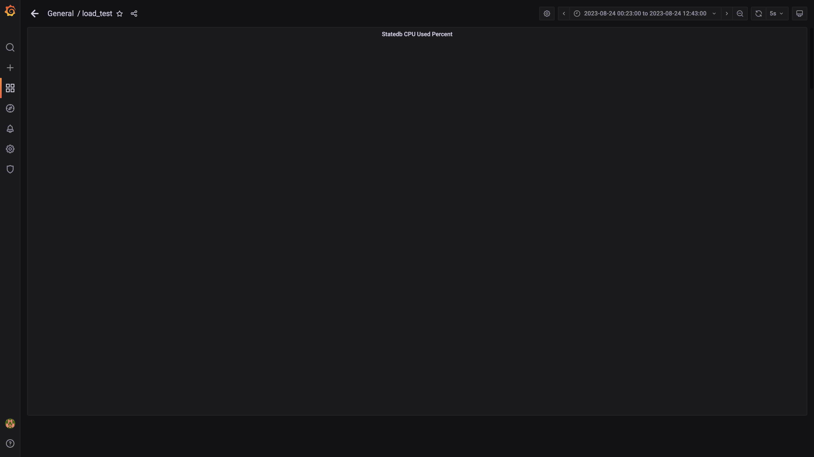

### Cpu consumed by cloudconnectoringestion

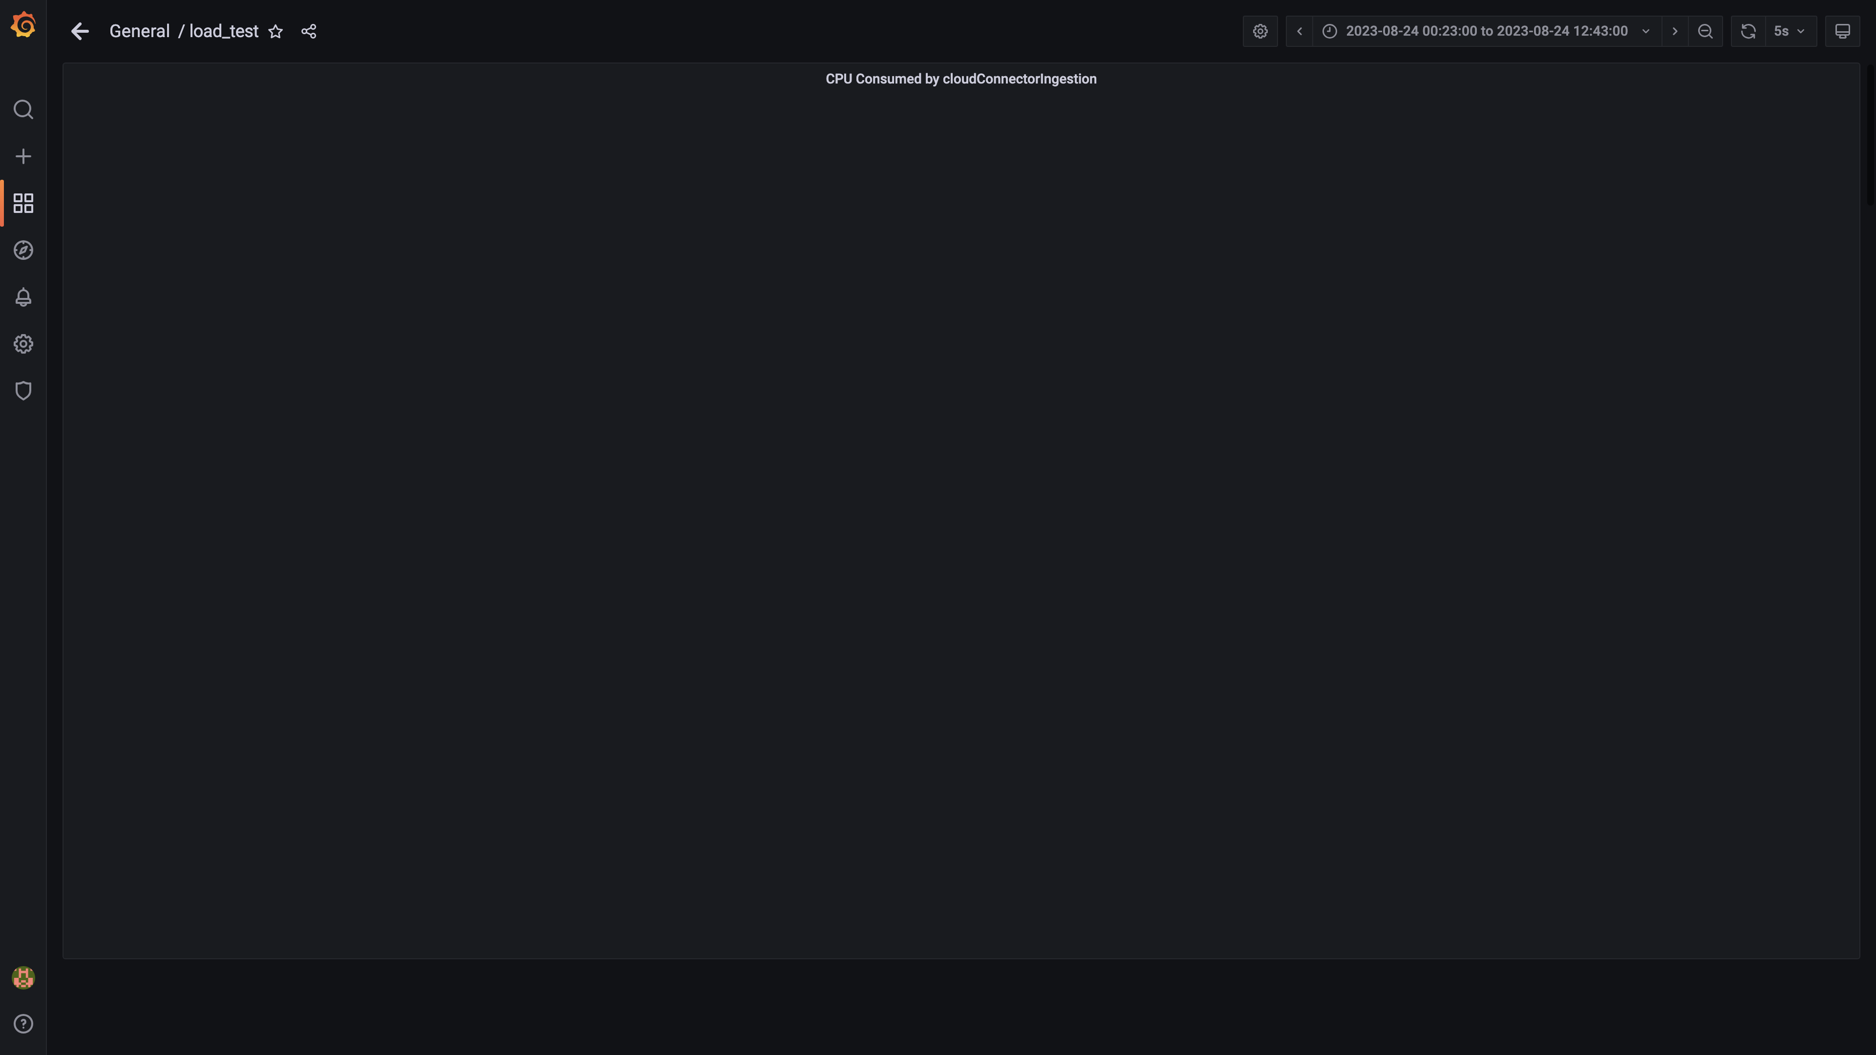

### Cpu consumed by tls

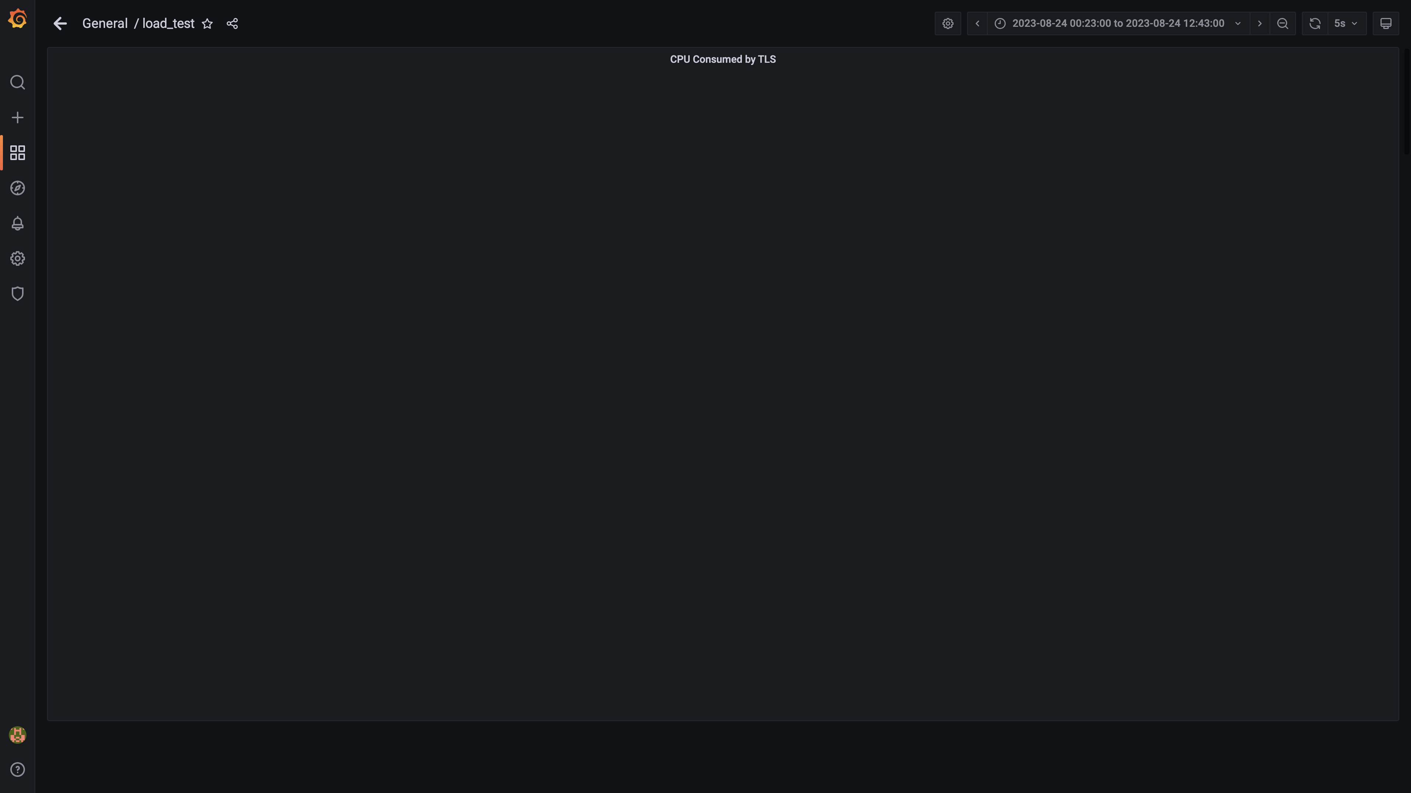

### Postgres-configdb cpu used percentage

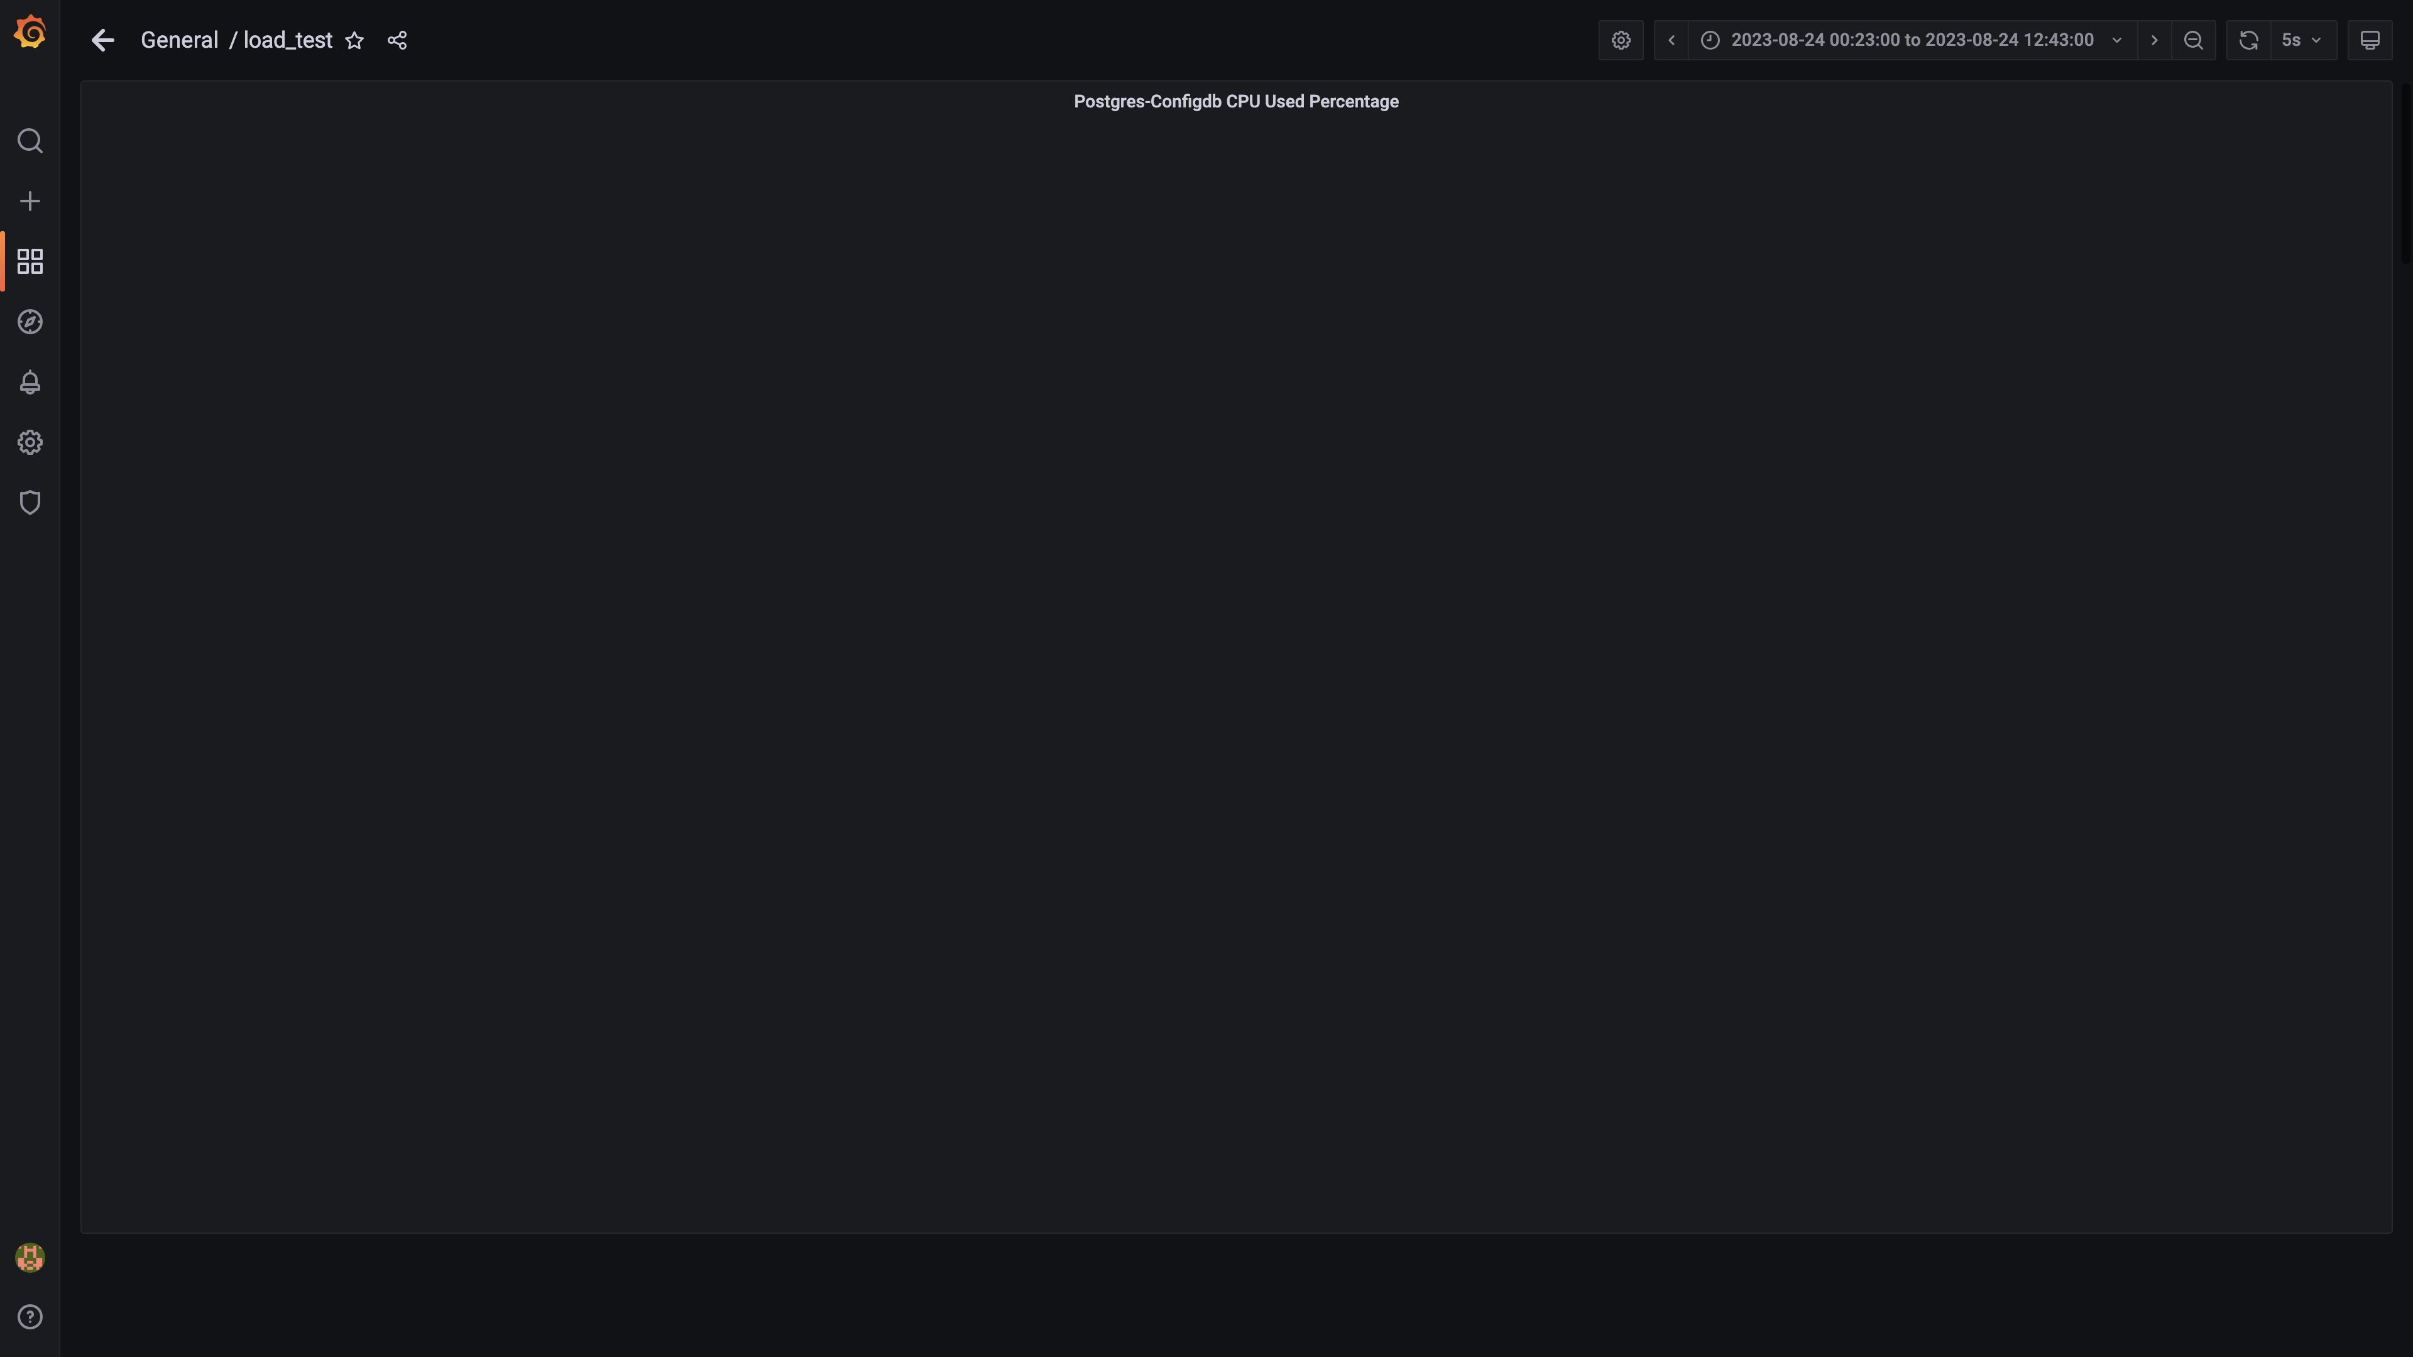

### Kafka cpu used percentage

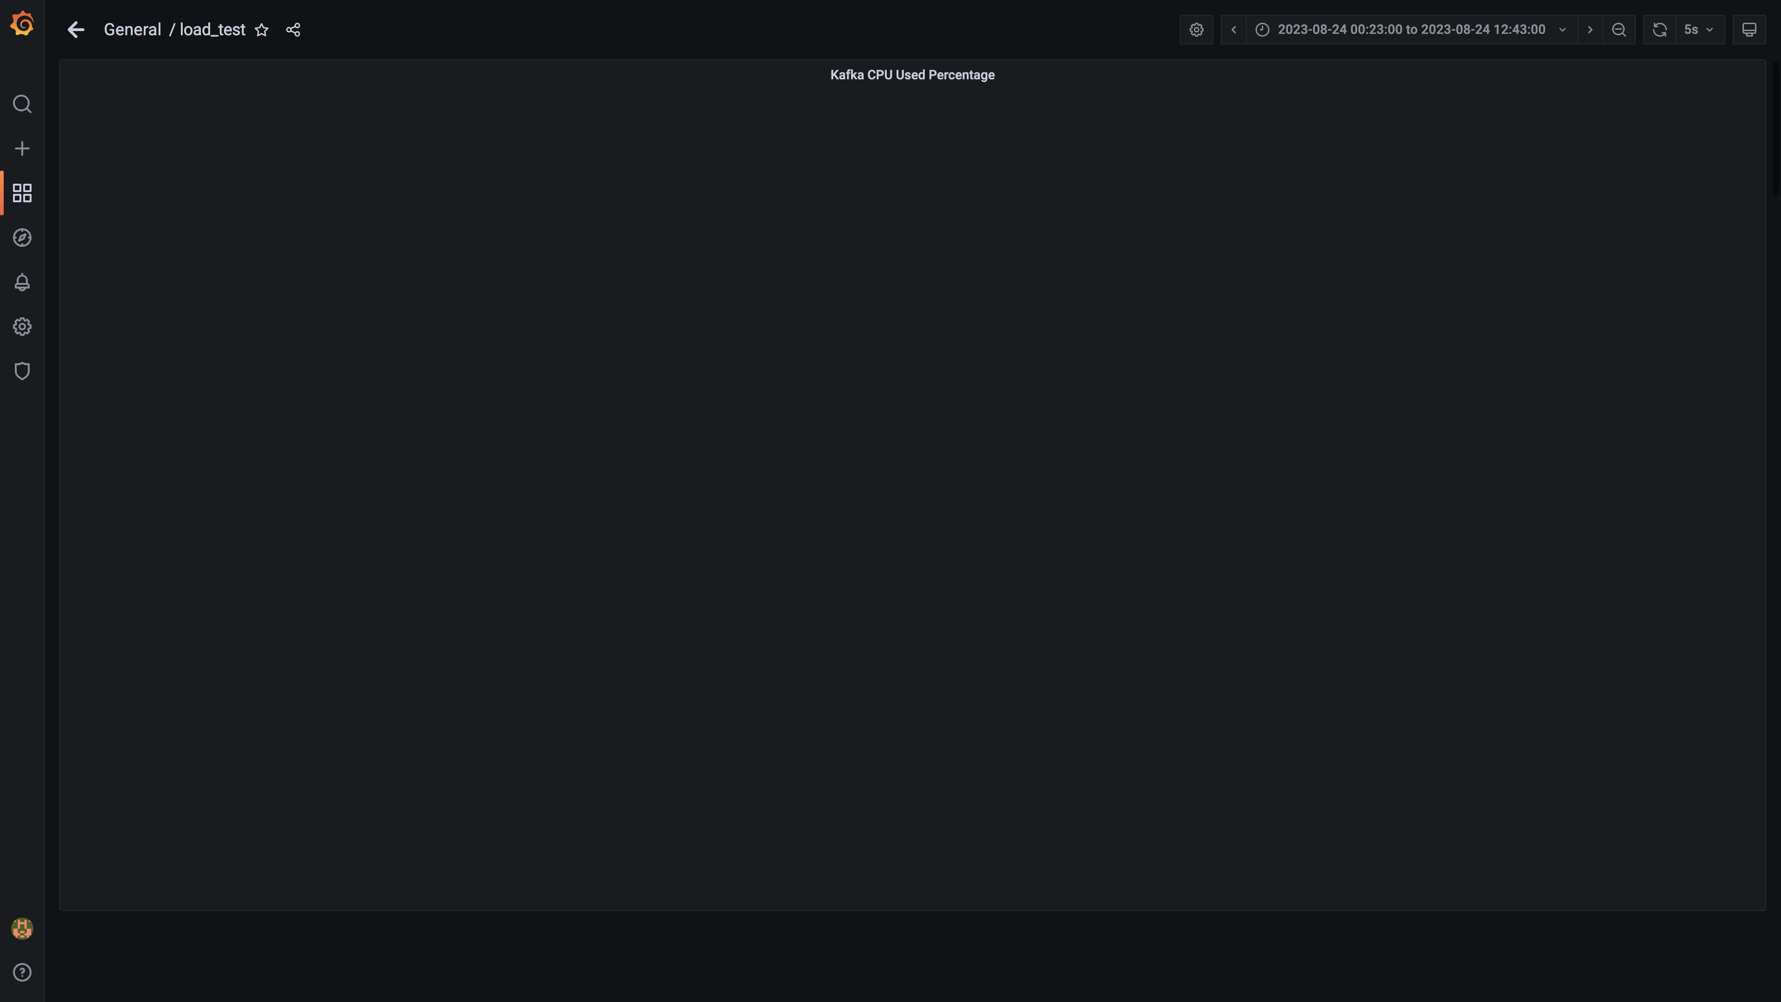

### Cpu used by data-archival

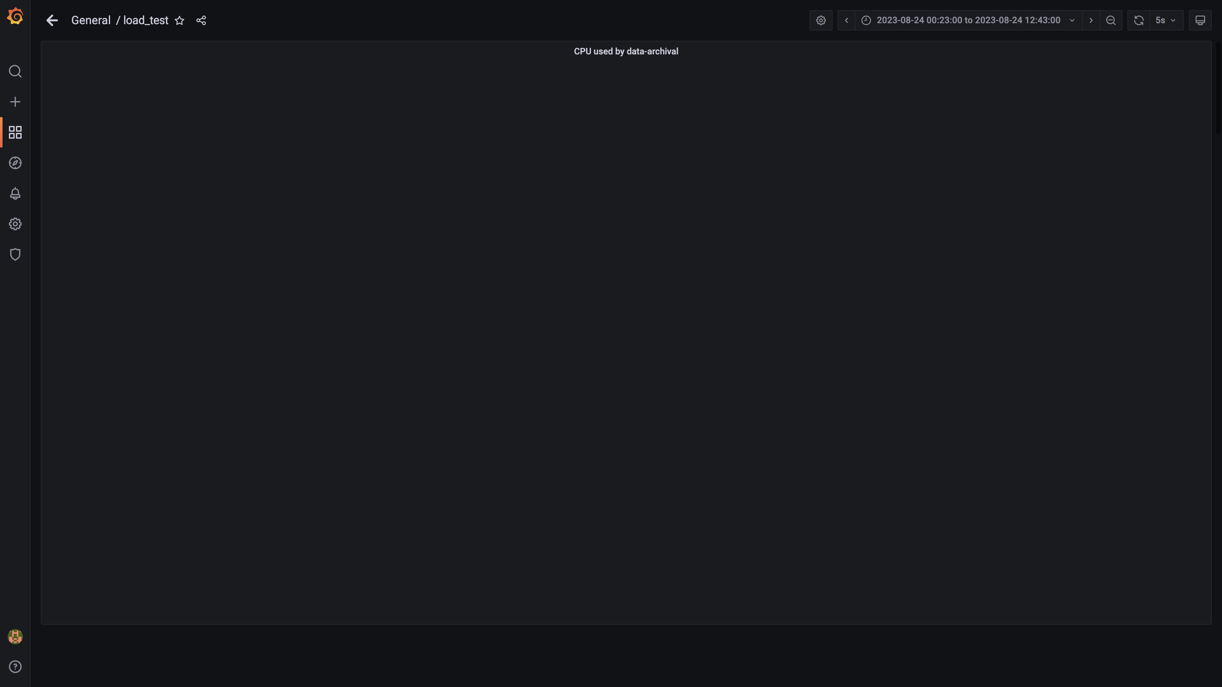

### Cpu consumed by osqueryingestion

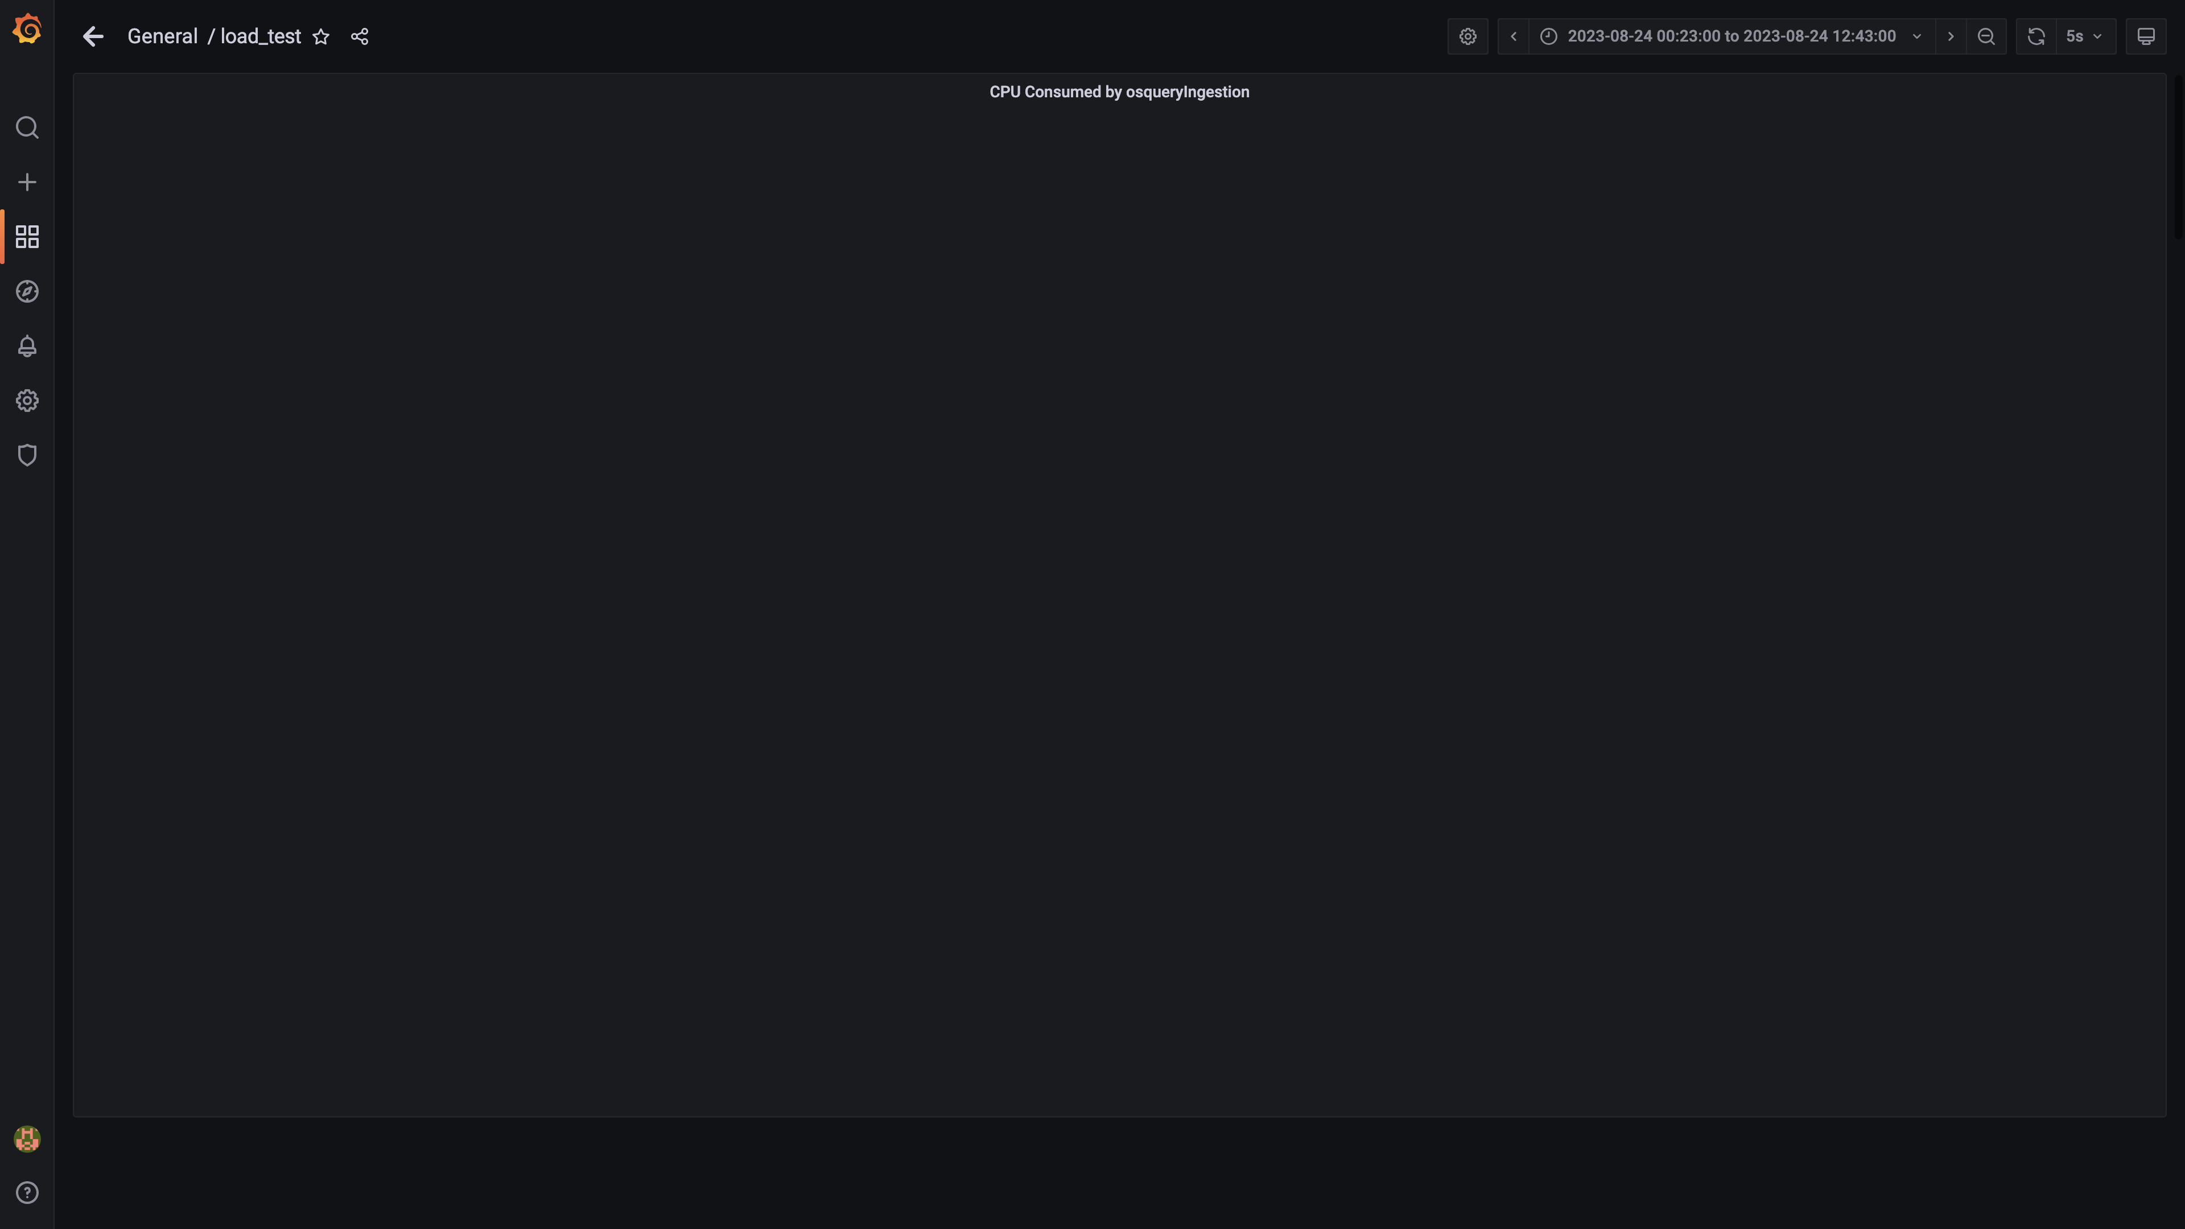

### Cpu consumed by logger

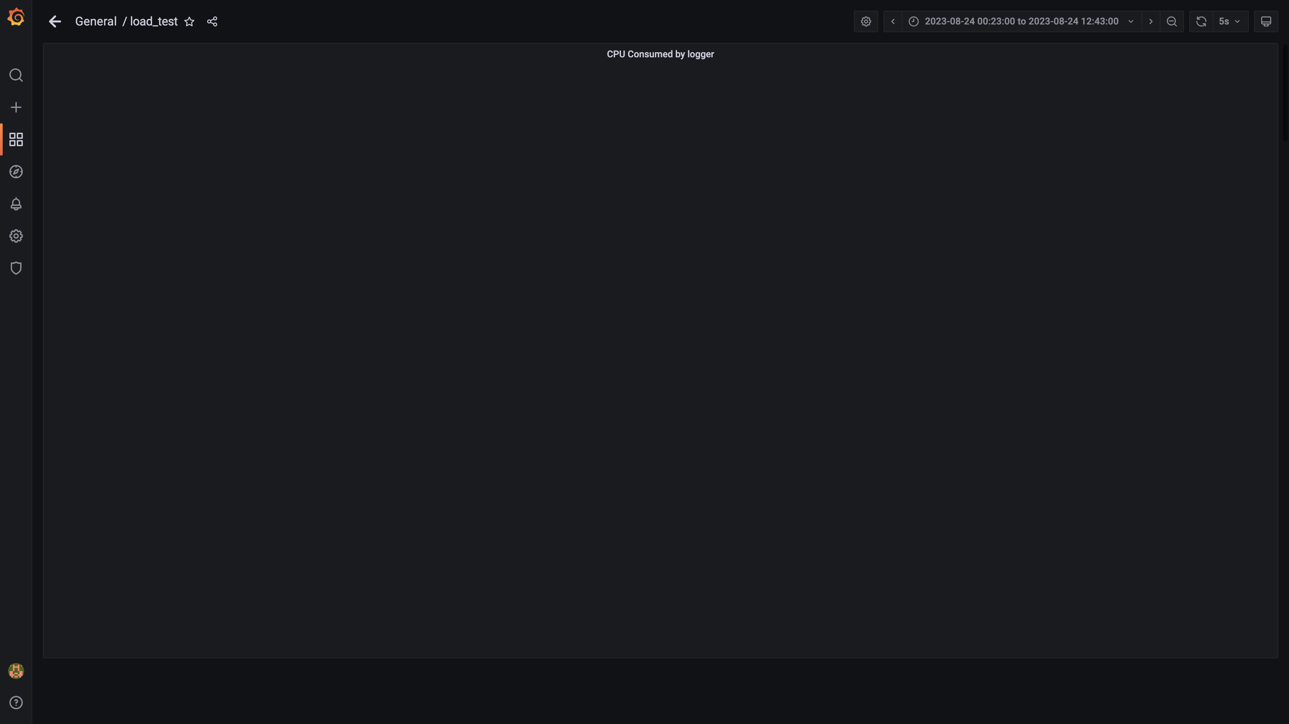

### Cpu consumed by trino

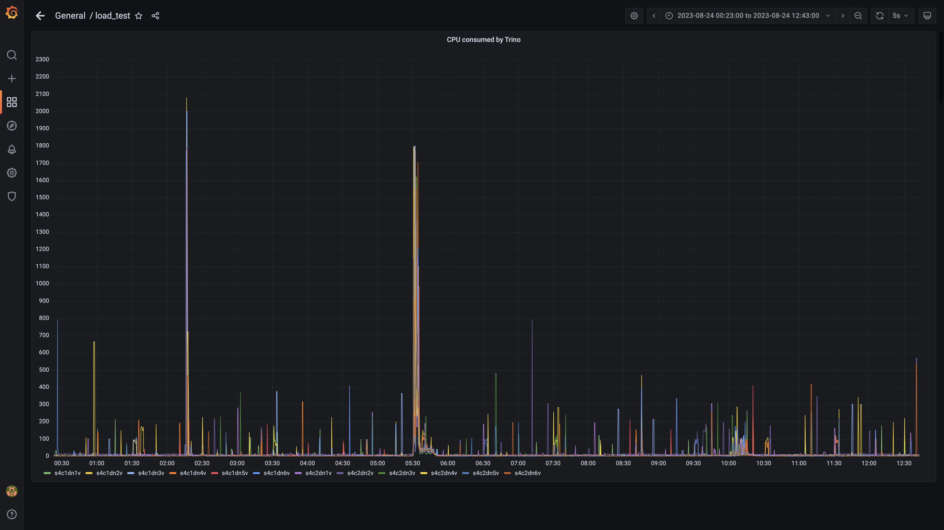

### Debezium cpu usage

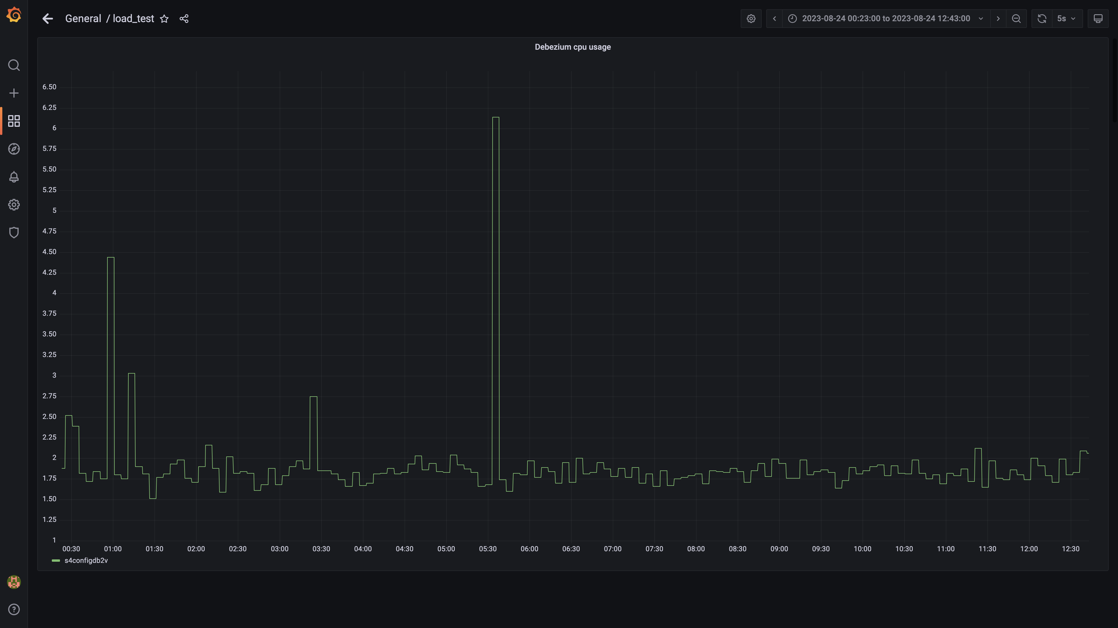

### Cpu consumed by orc-compaction:

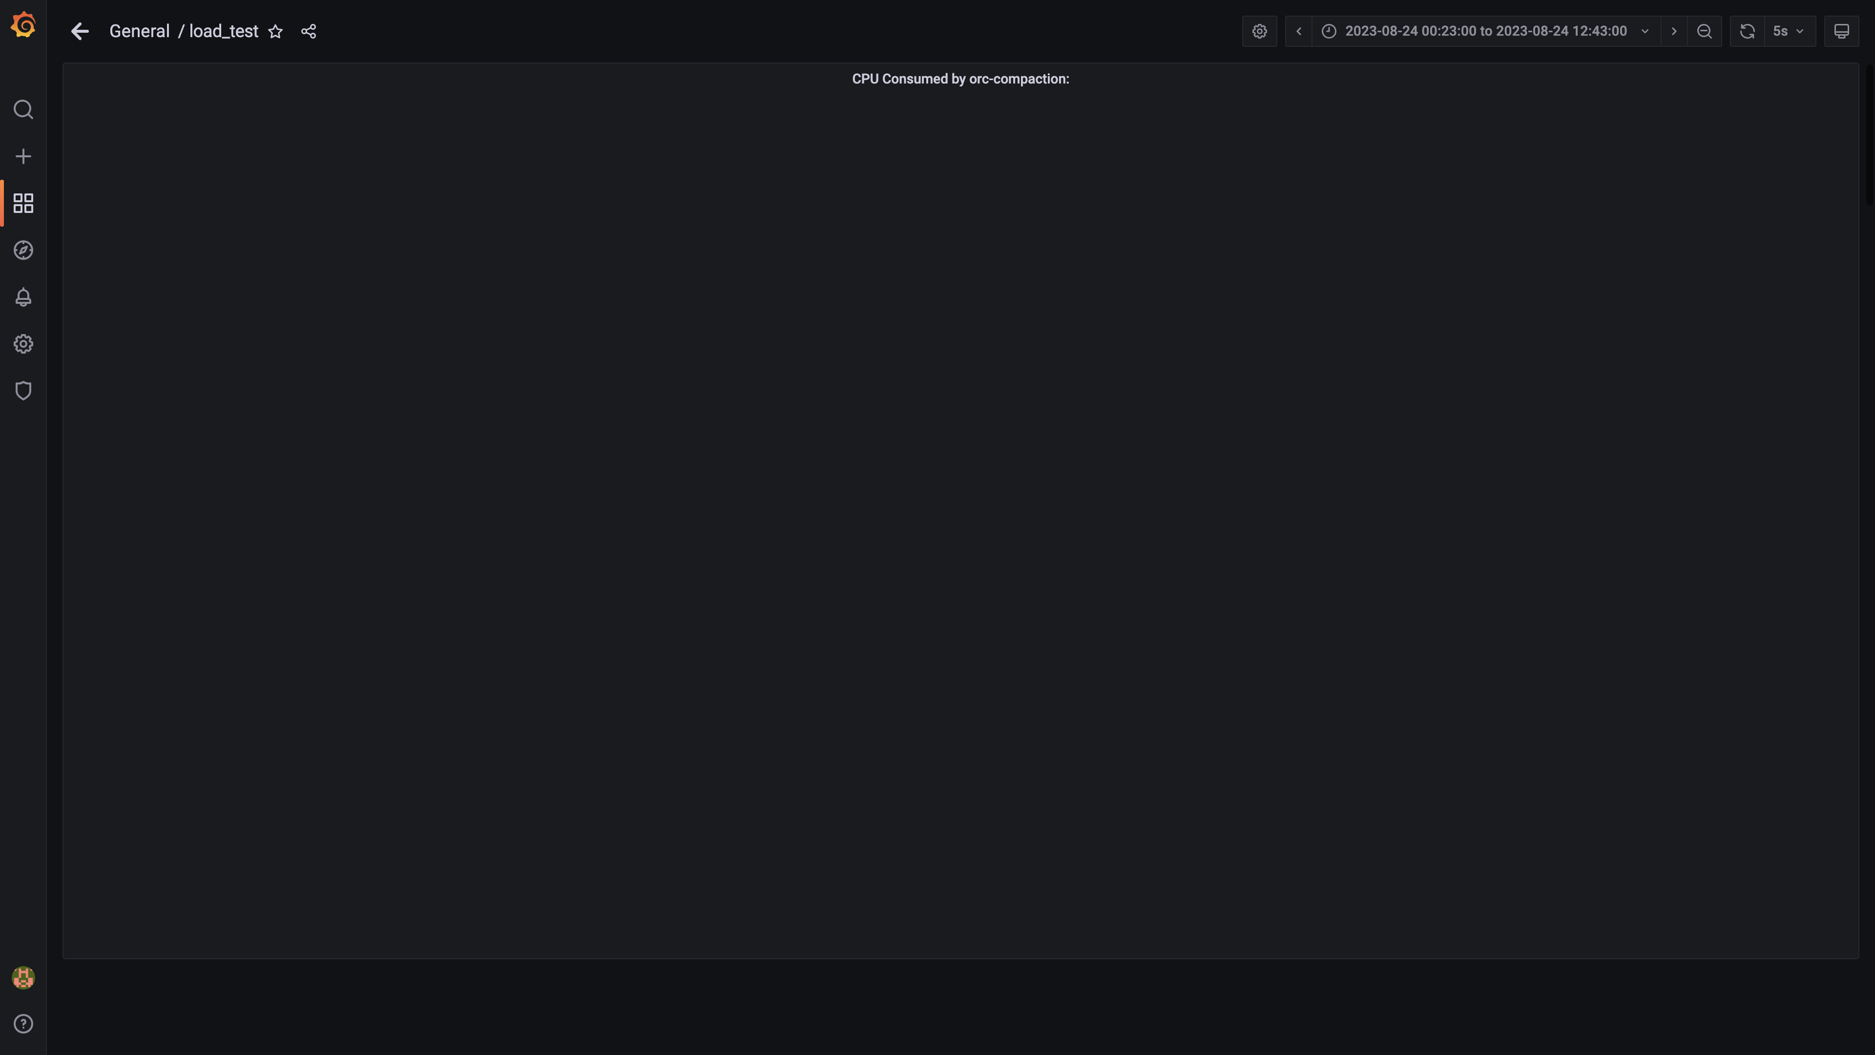

### Cpu consumed by spark-worker

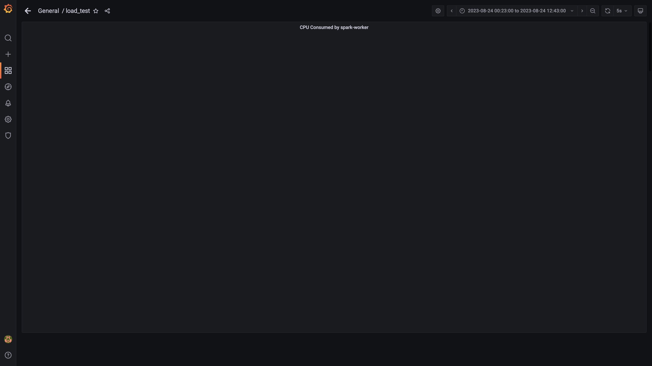

### Cpu consumed by ruleengine

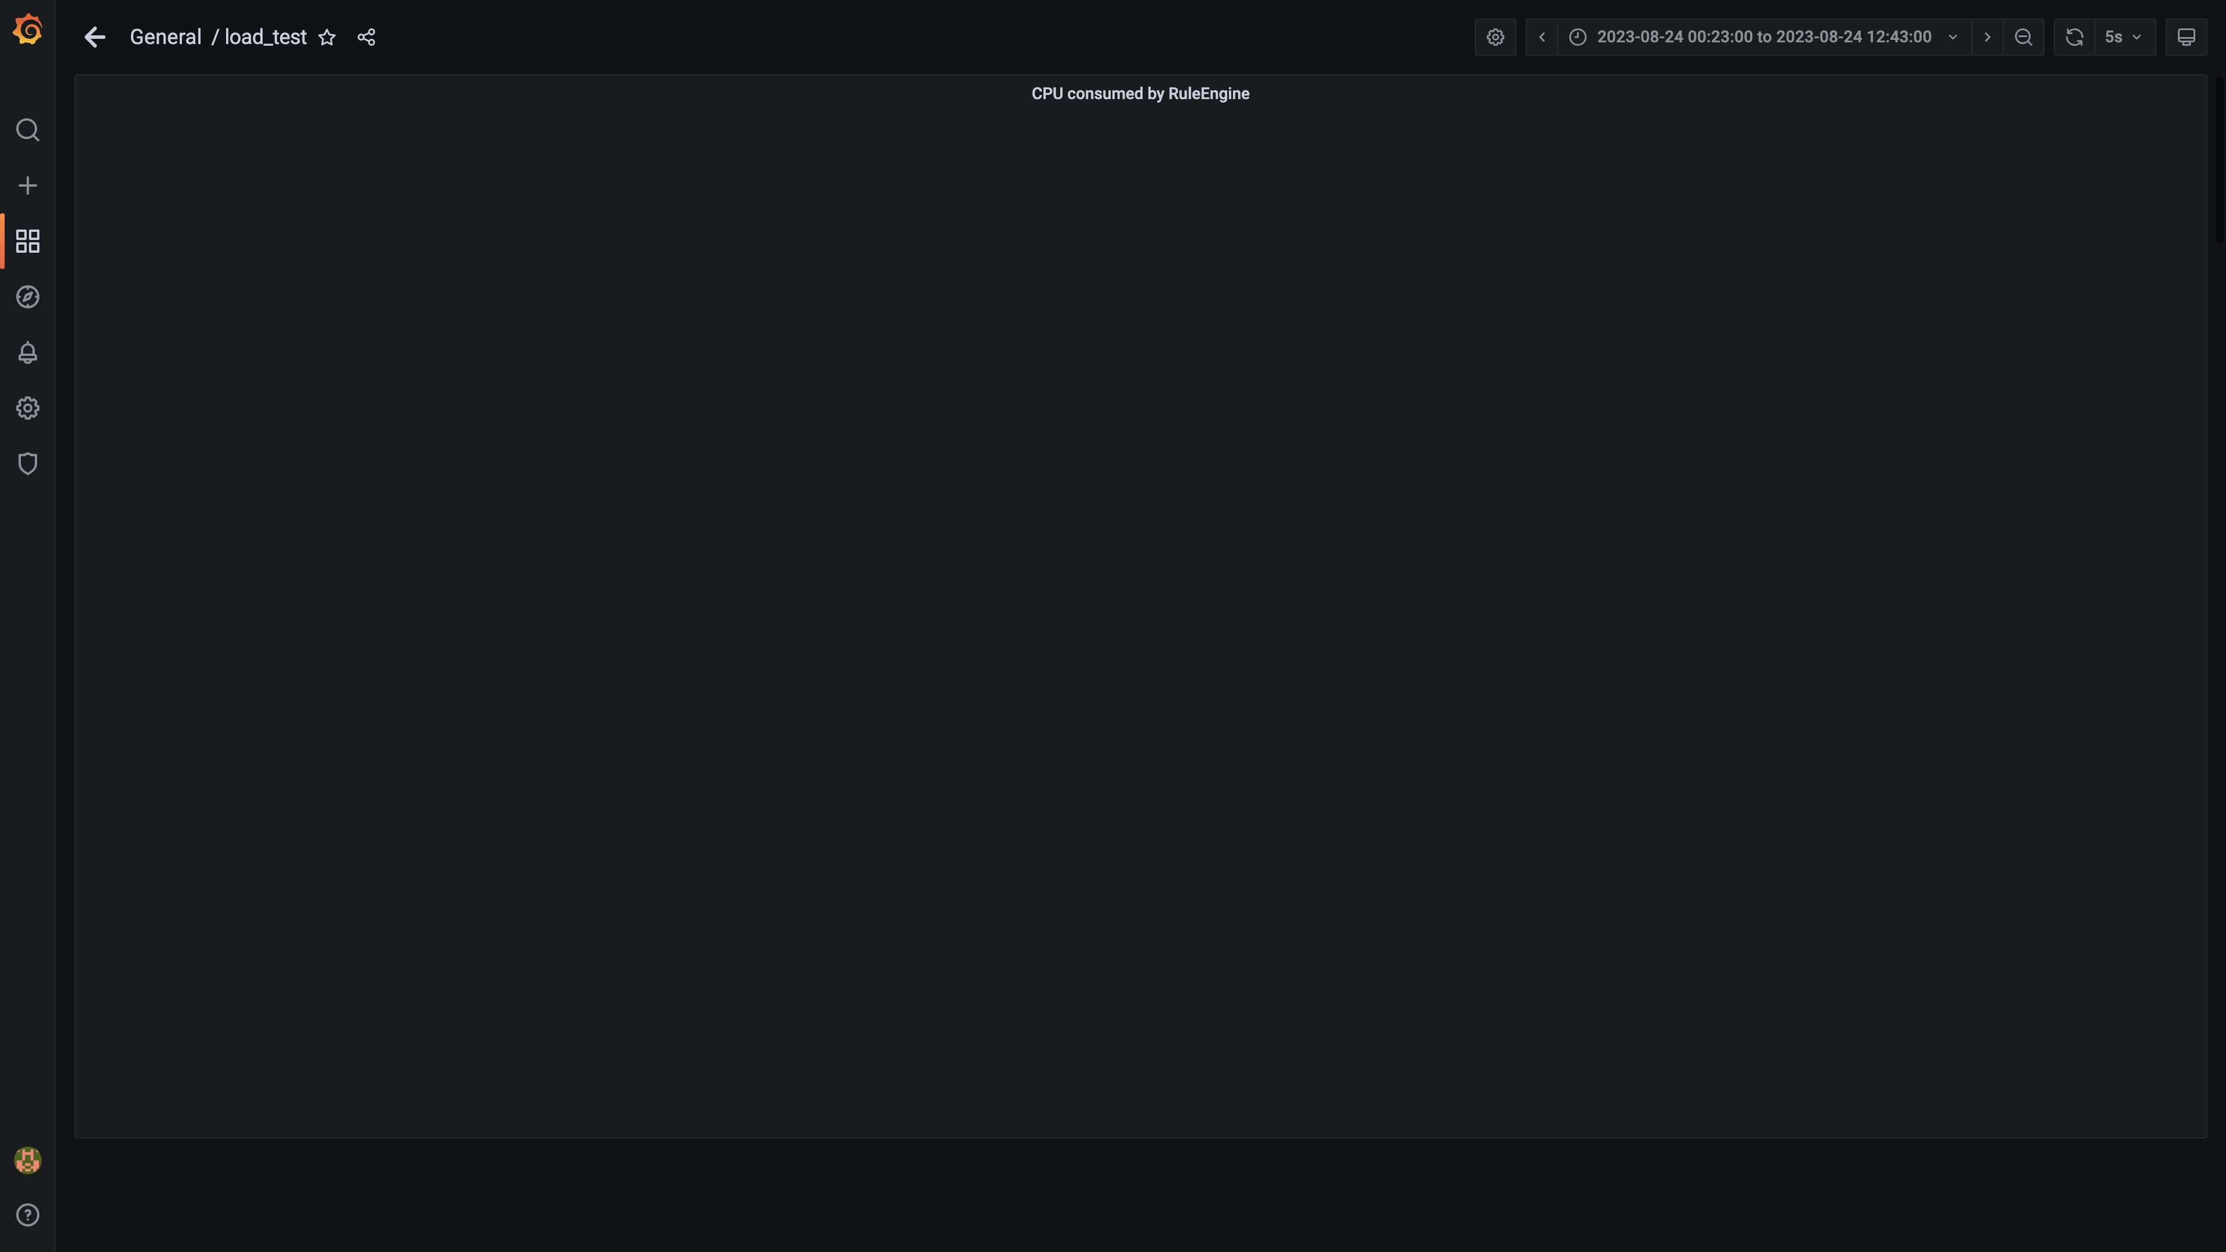

### Cpu consumed by airflow

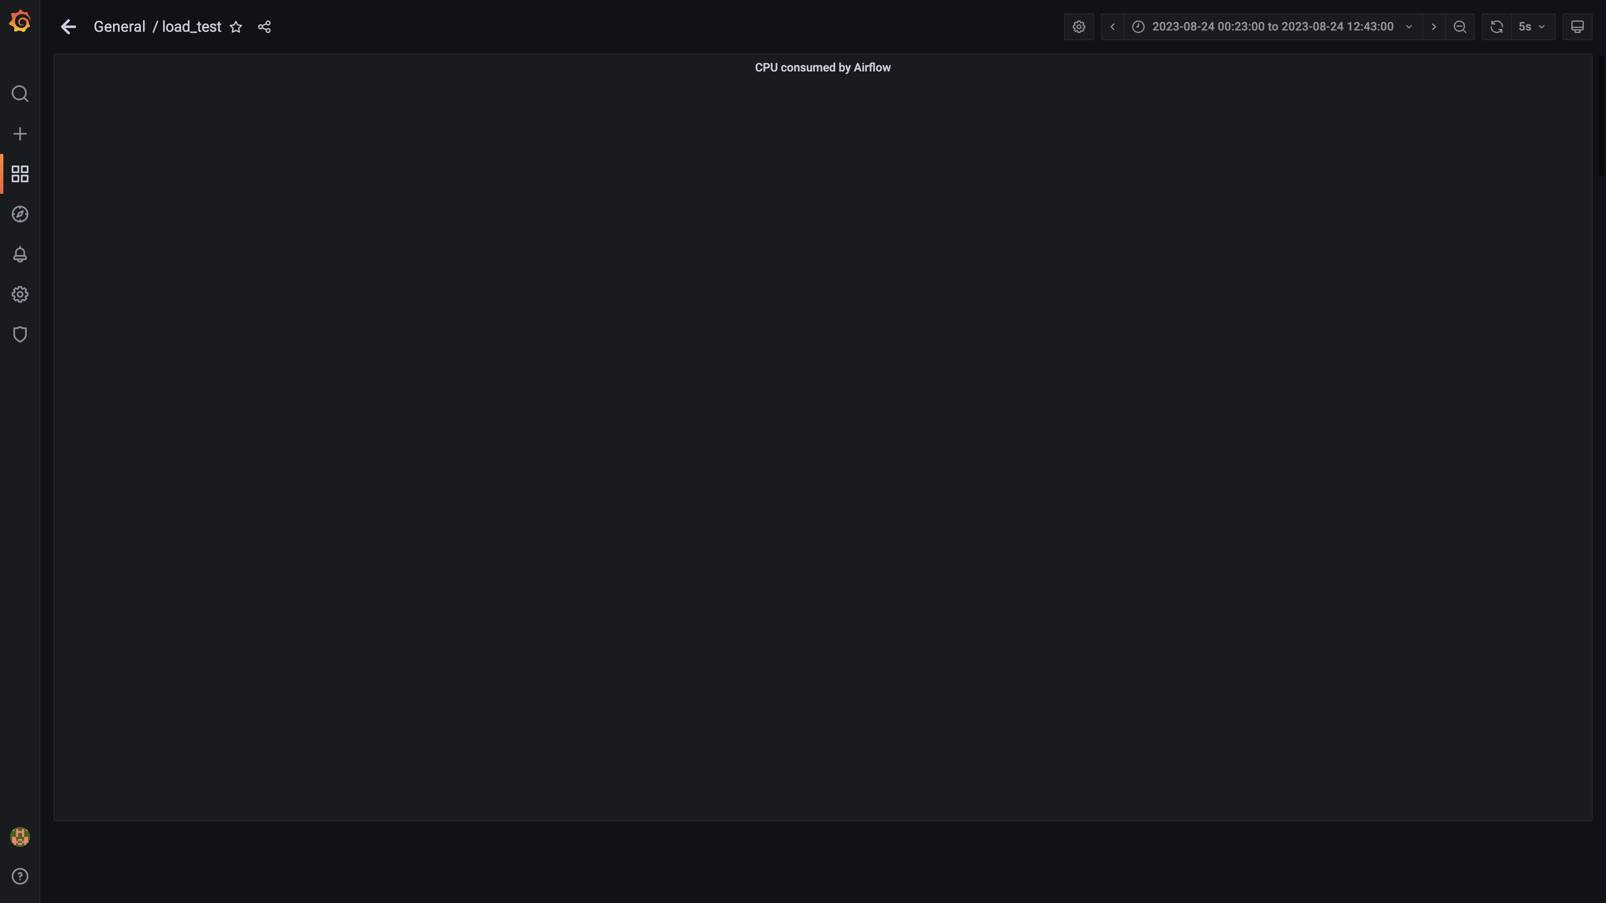

### Cpu consumed by redis server

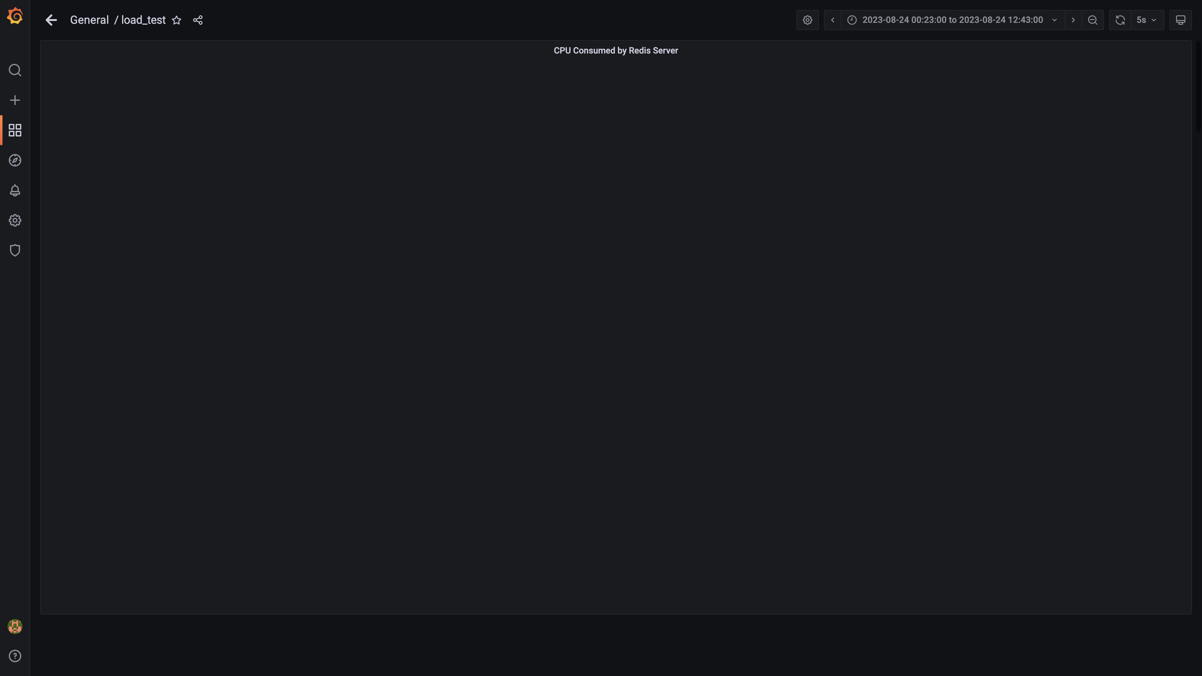

### Cpu consumed by spark-master

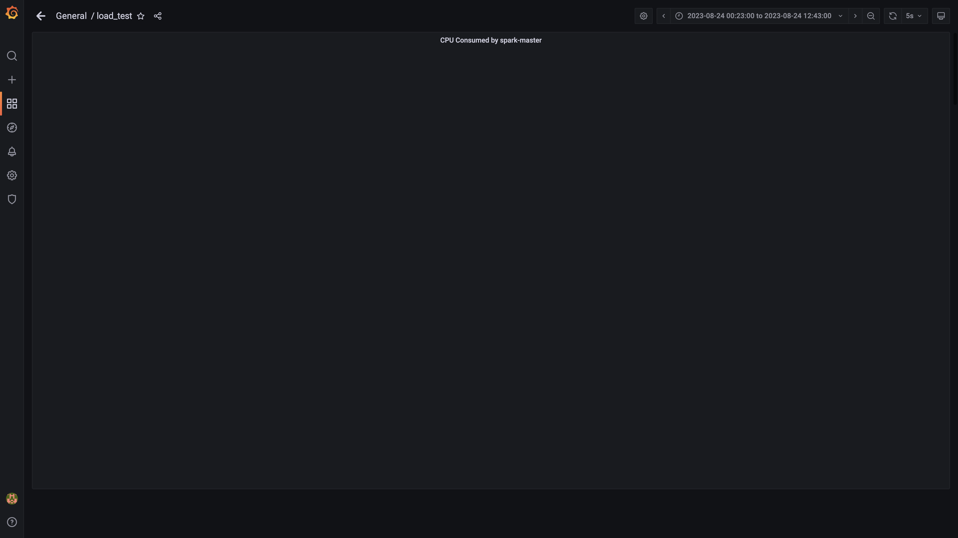

### Kafka lag for cloudconnectoringestion

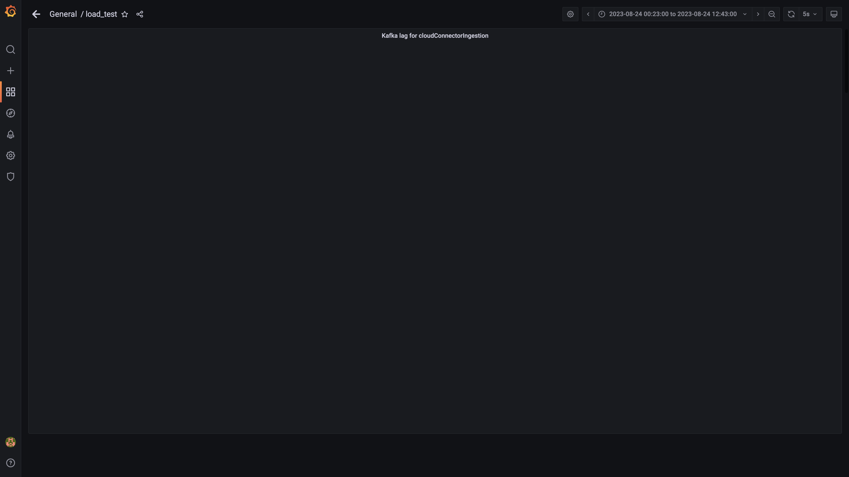

### Inject and drain rate for cloudconnectorsingestion

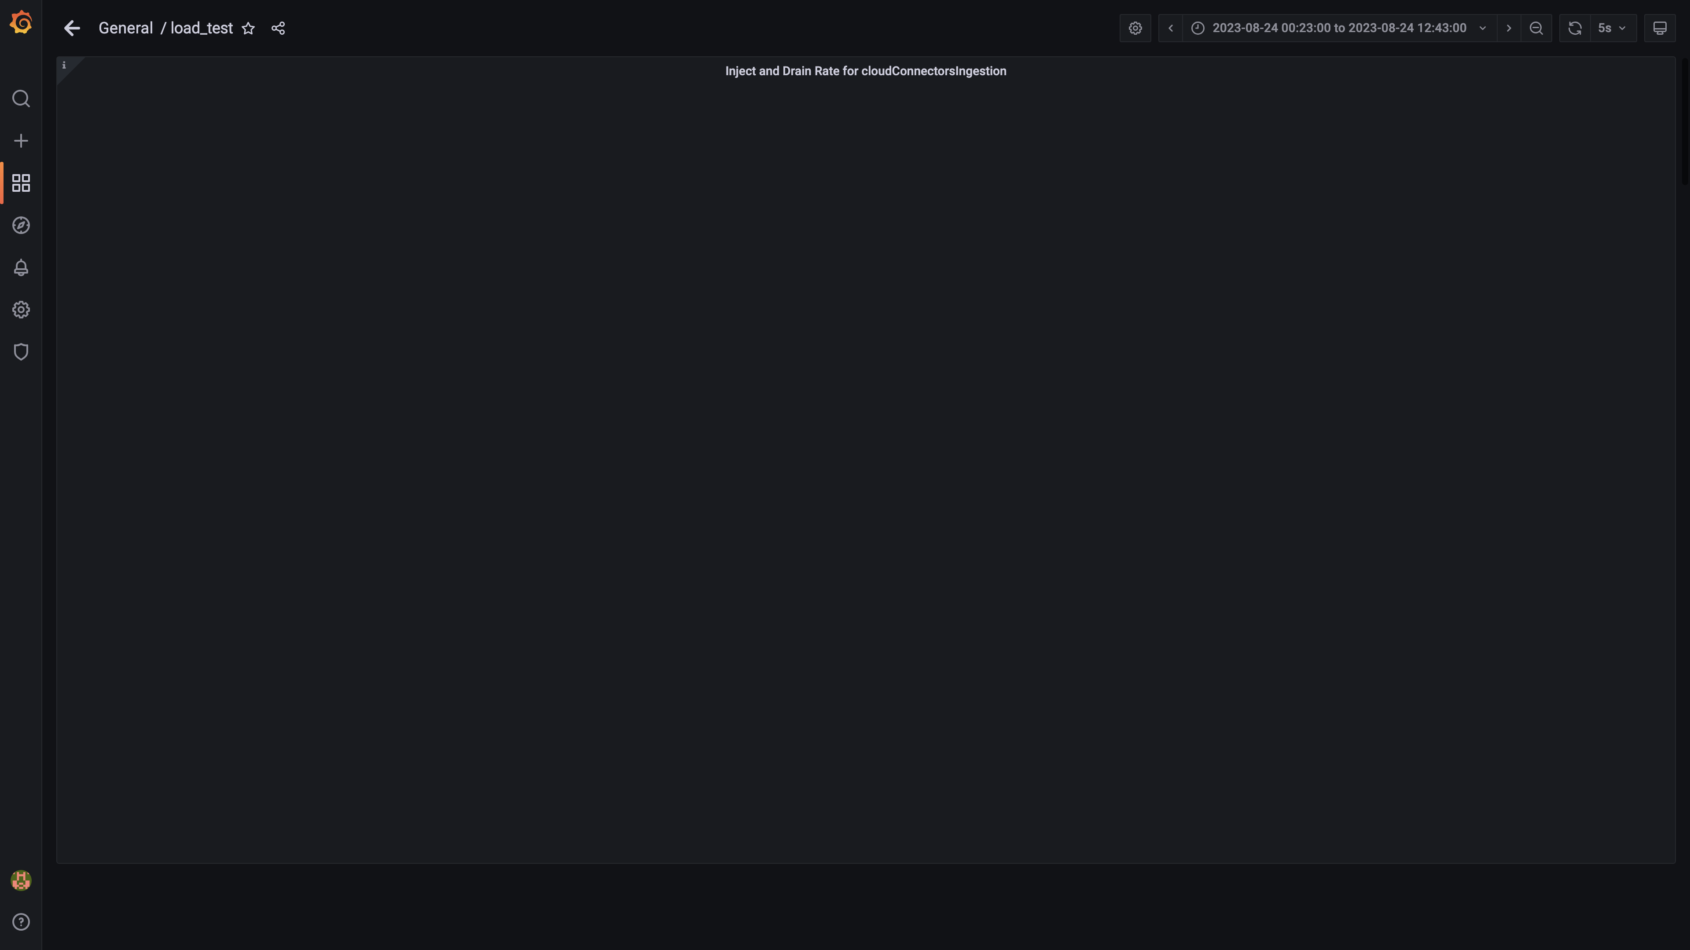

### Kafka lag for cloudqueryinventorygroup

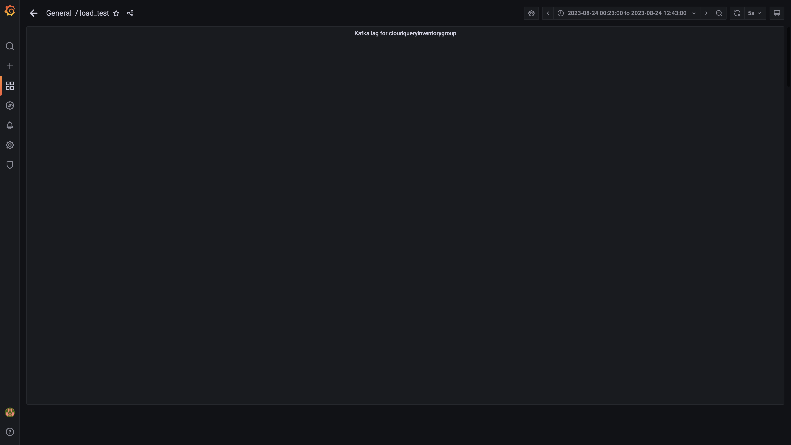

### Kafka lag for cloudtraileventsgroup

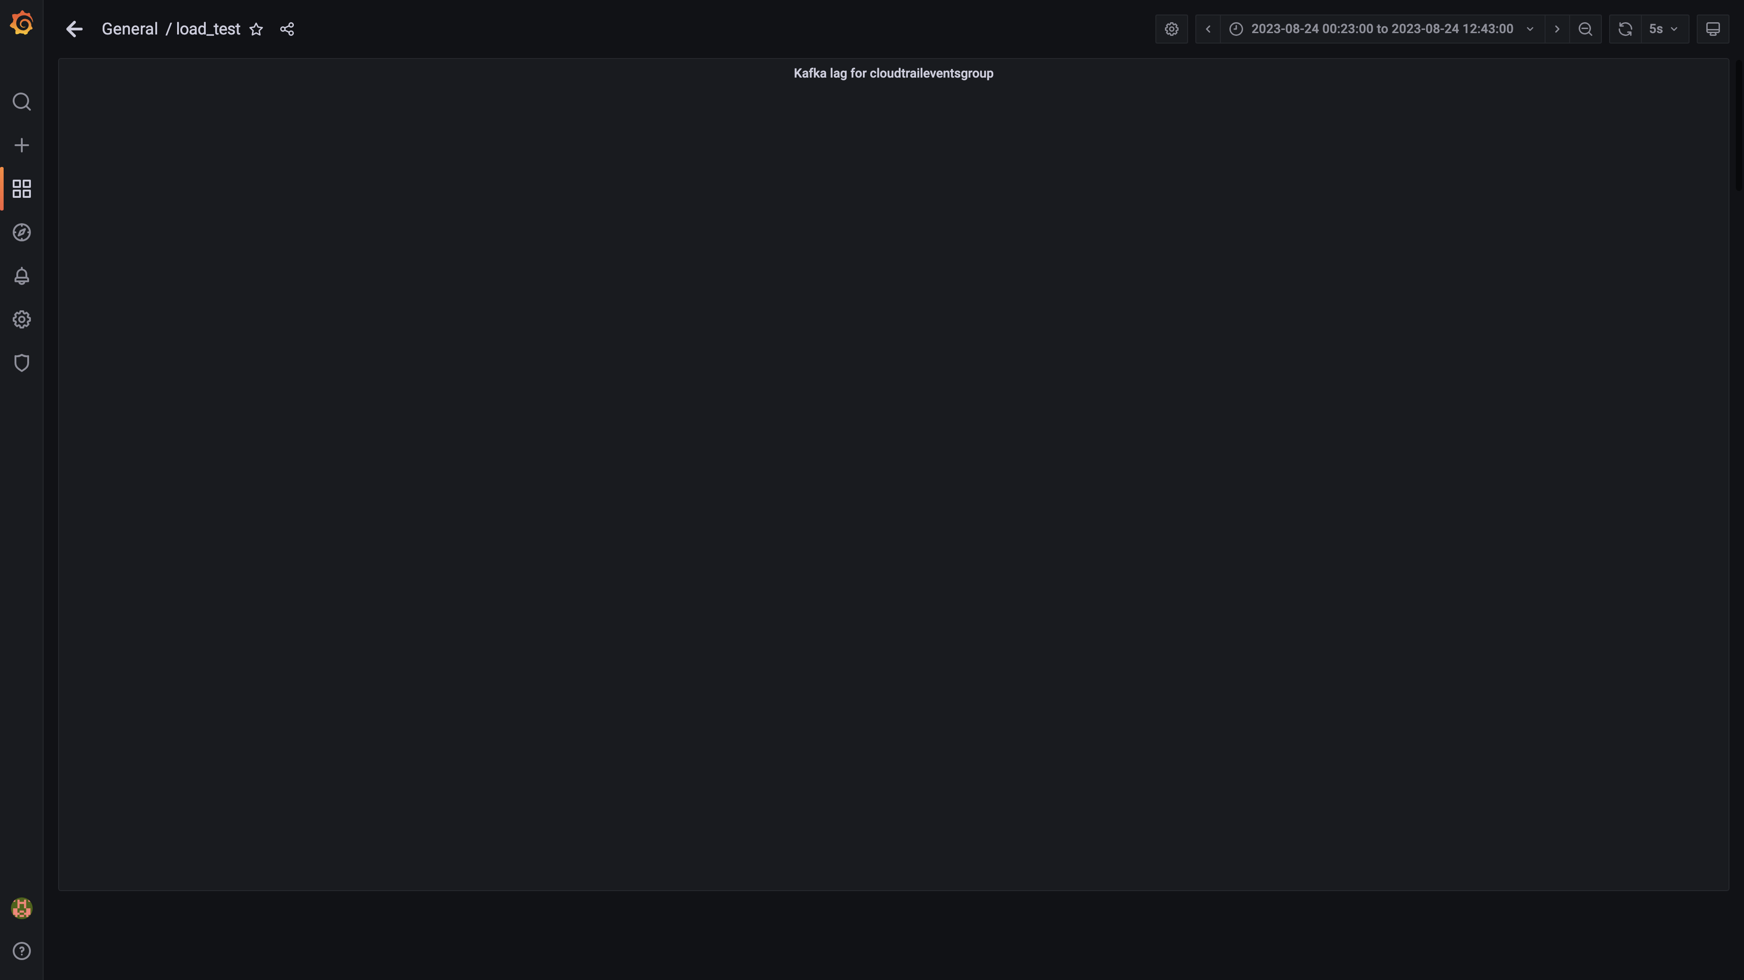

### Kafka lag for cloudqueryeventsgroup

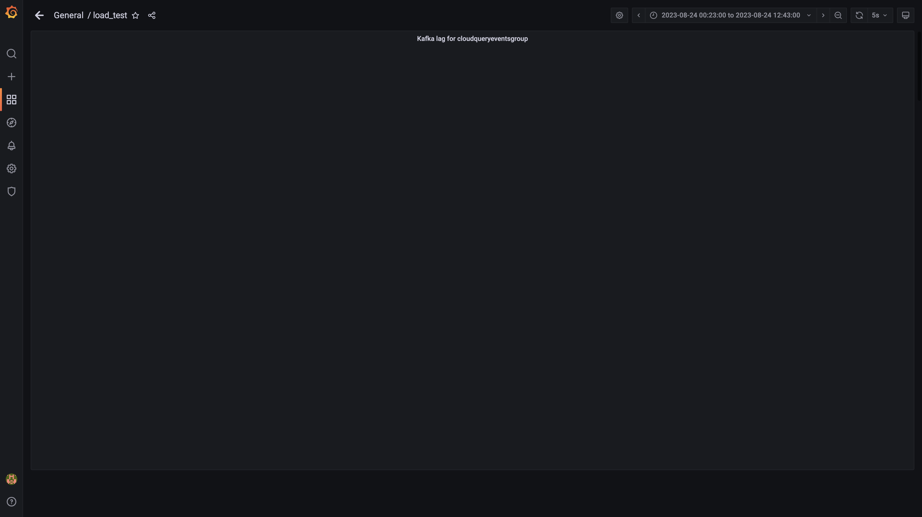

### Kafka lag for ruleenginecc group

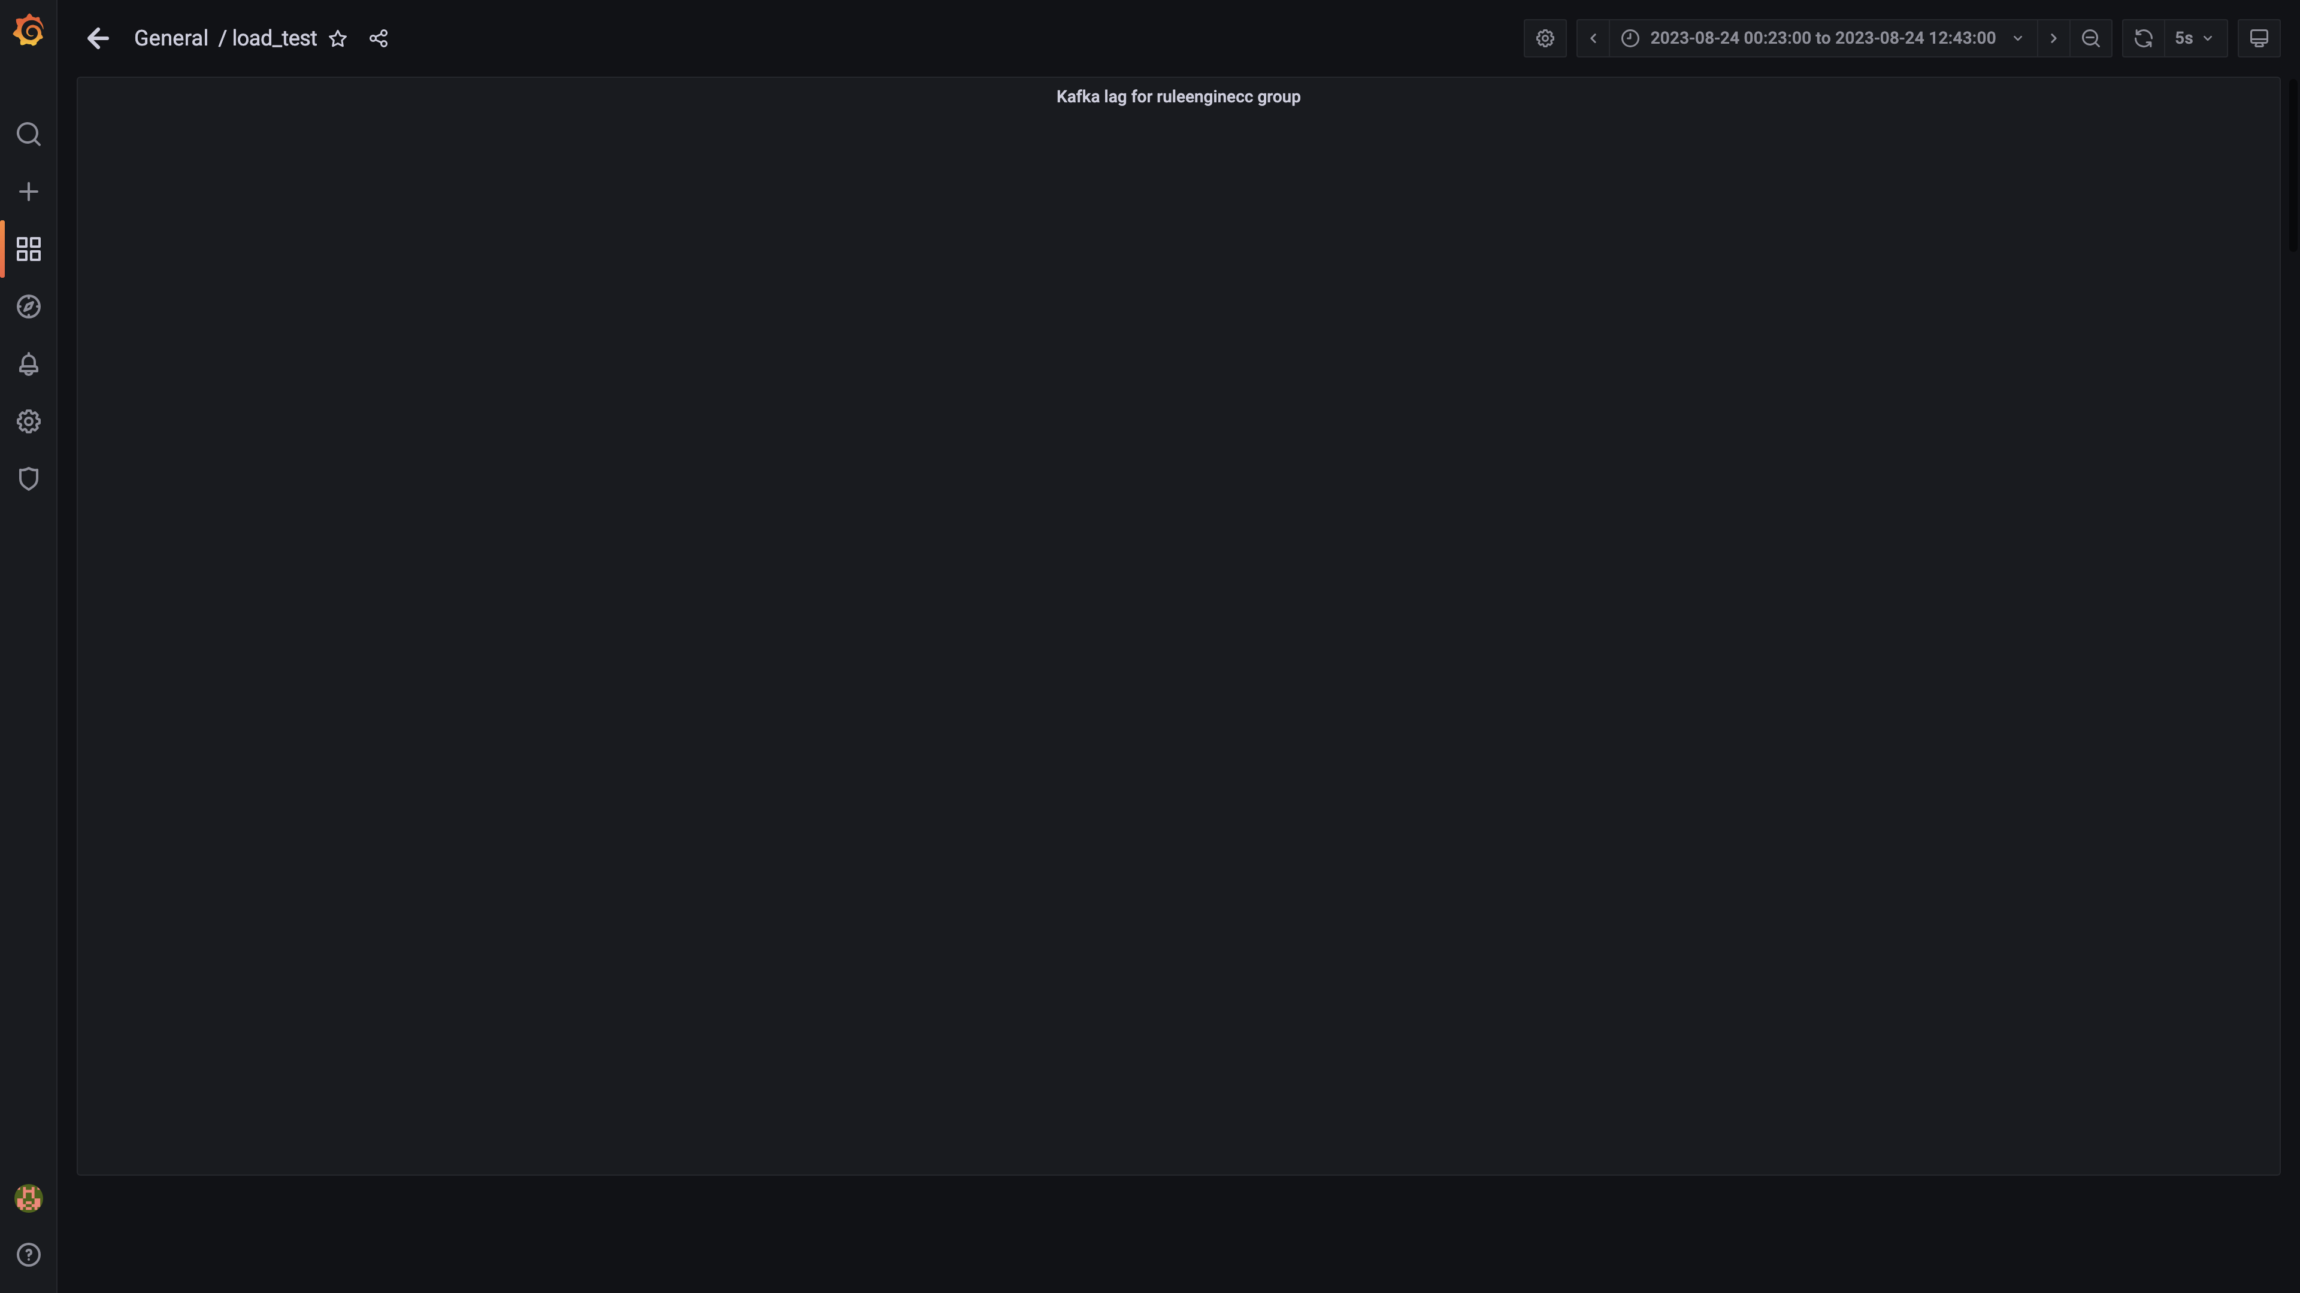

### Kafka lag for cloudcompliancemanager

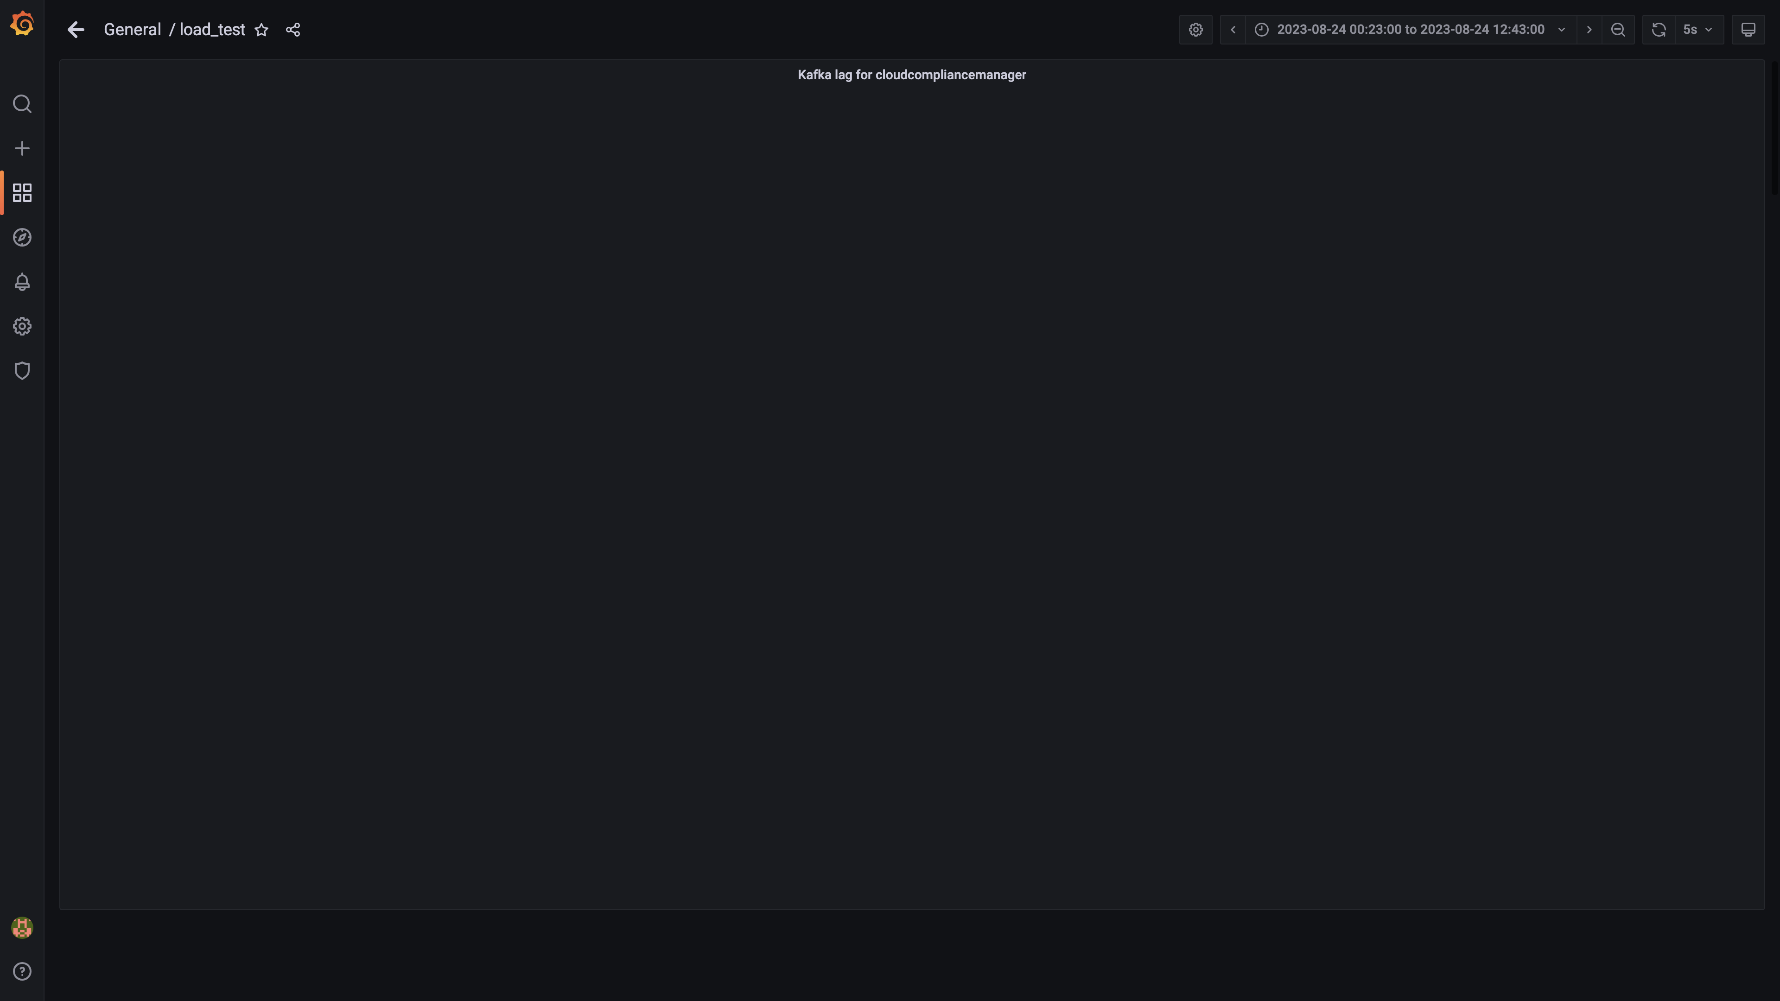

### Kafka lag for db-events

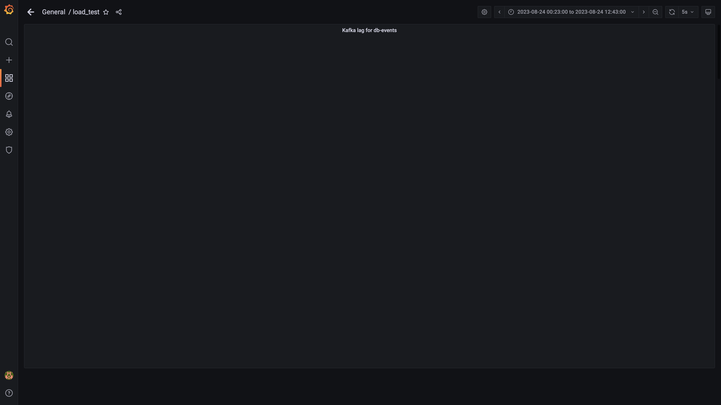

### Spark lag for eventsdbingestion

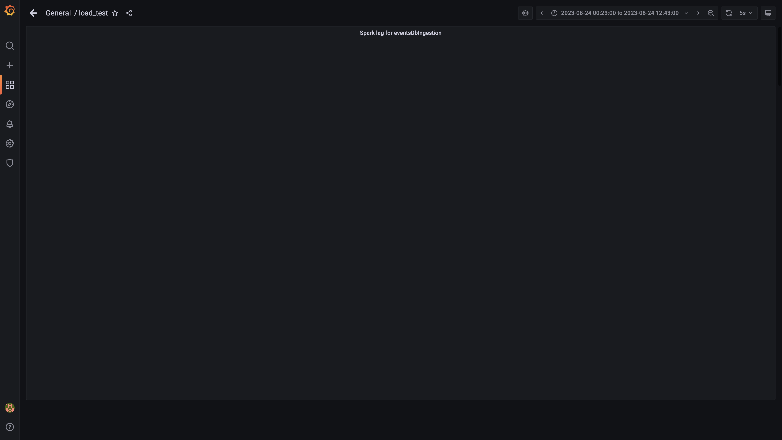

### Debezium replication lag

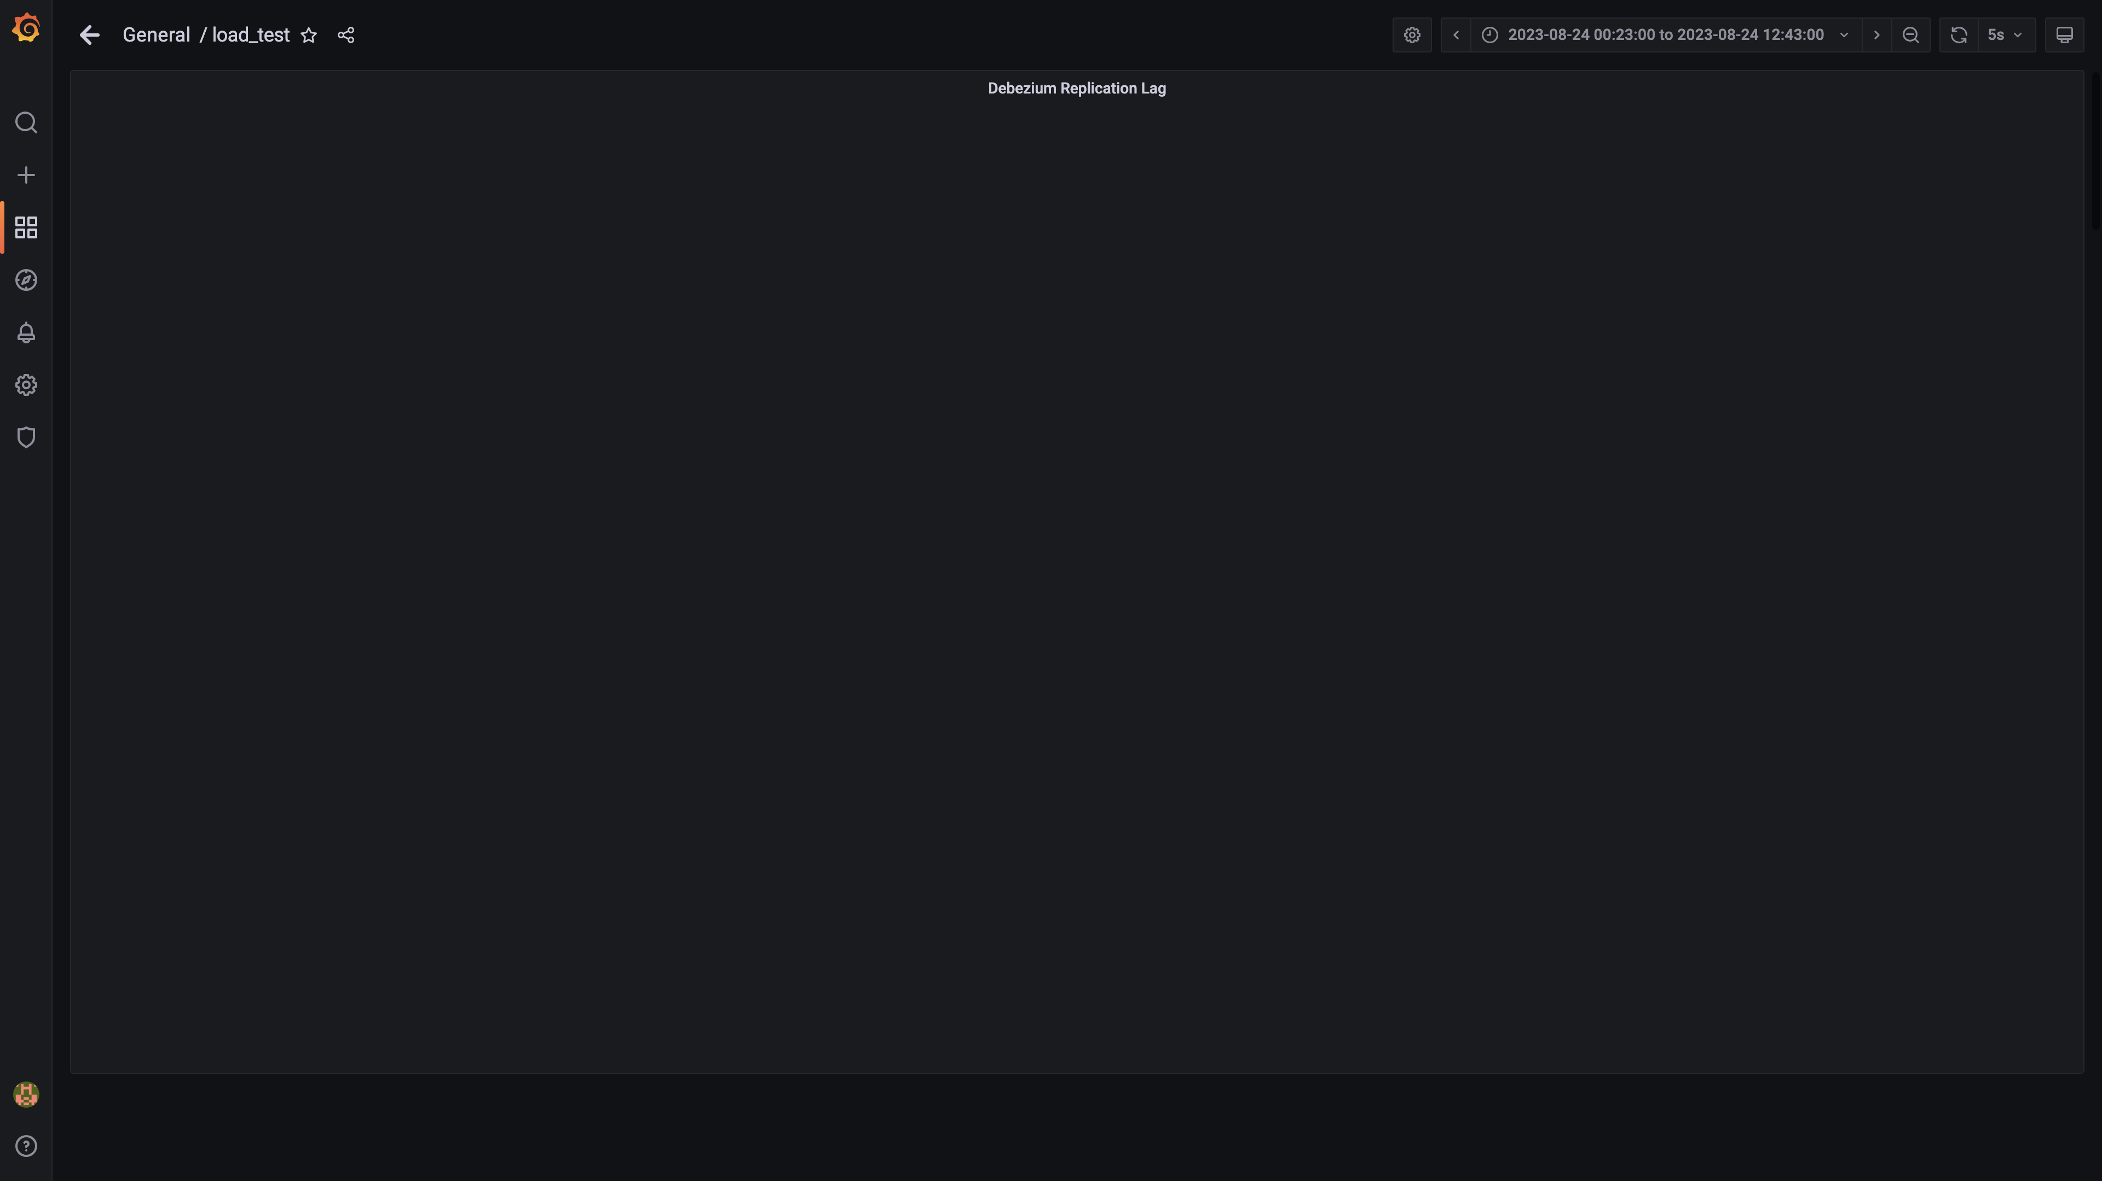

### Overall container memory and cpu usage

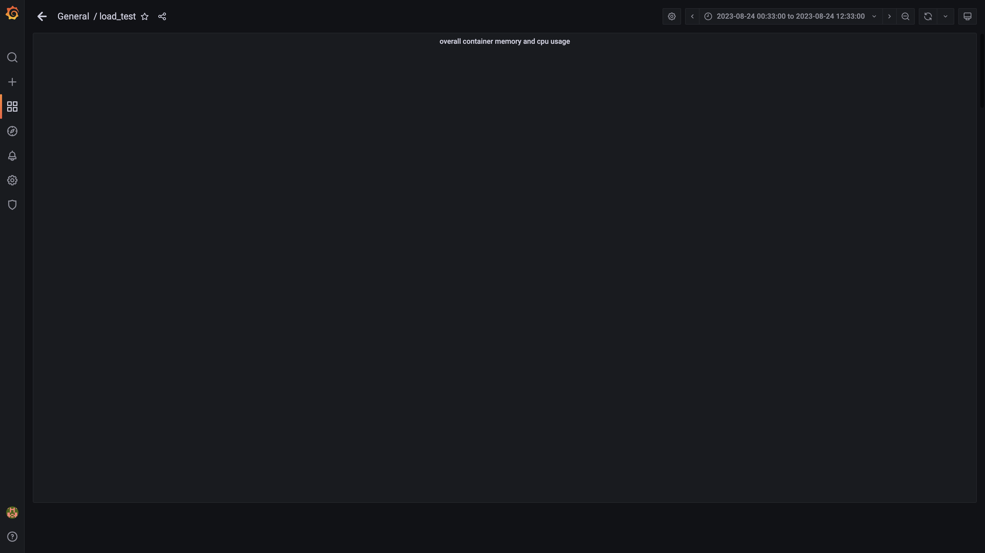

### Cpu and memory usages

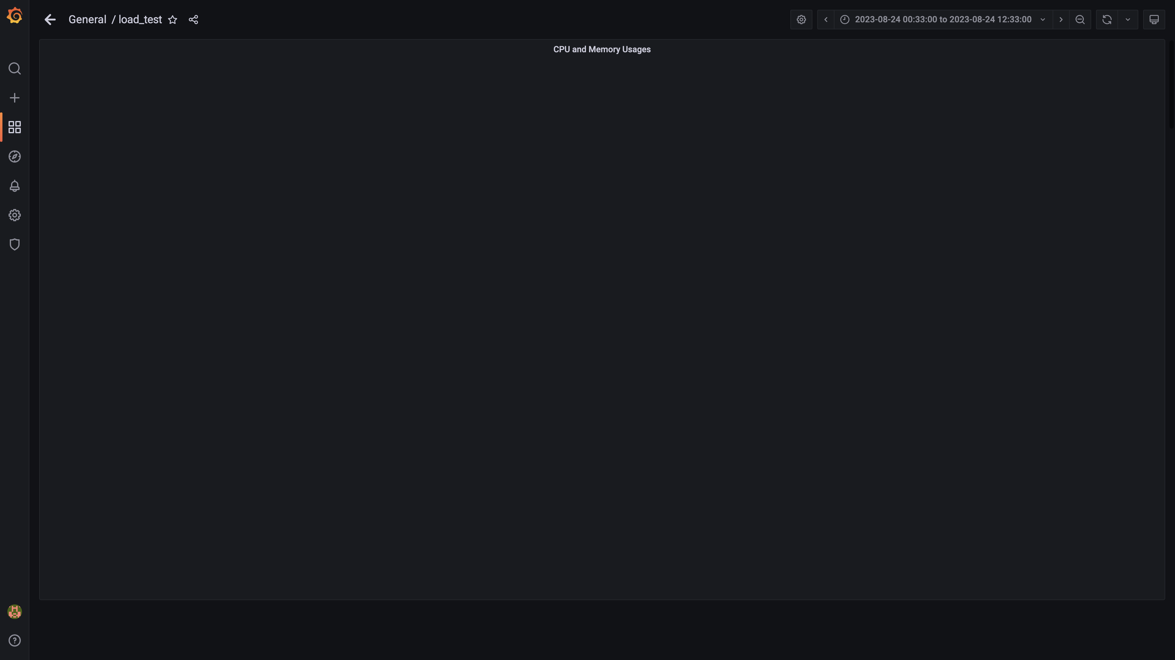

### Overall memory and cpu usages

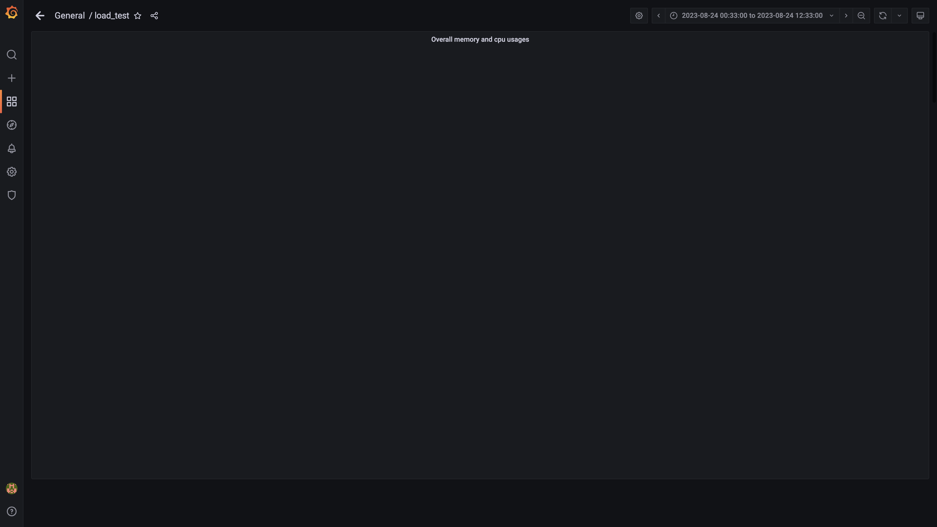

### Statedb errors

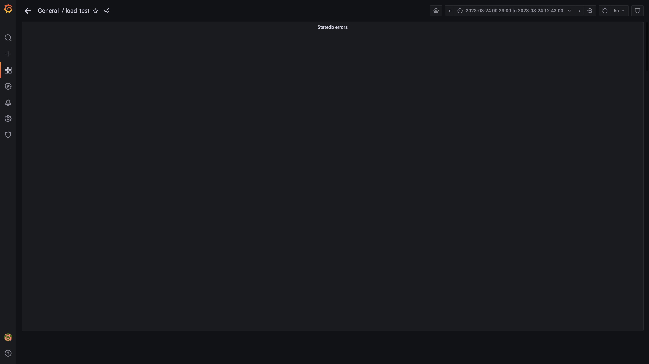

### Kafka disk used percentage

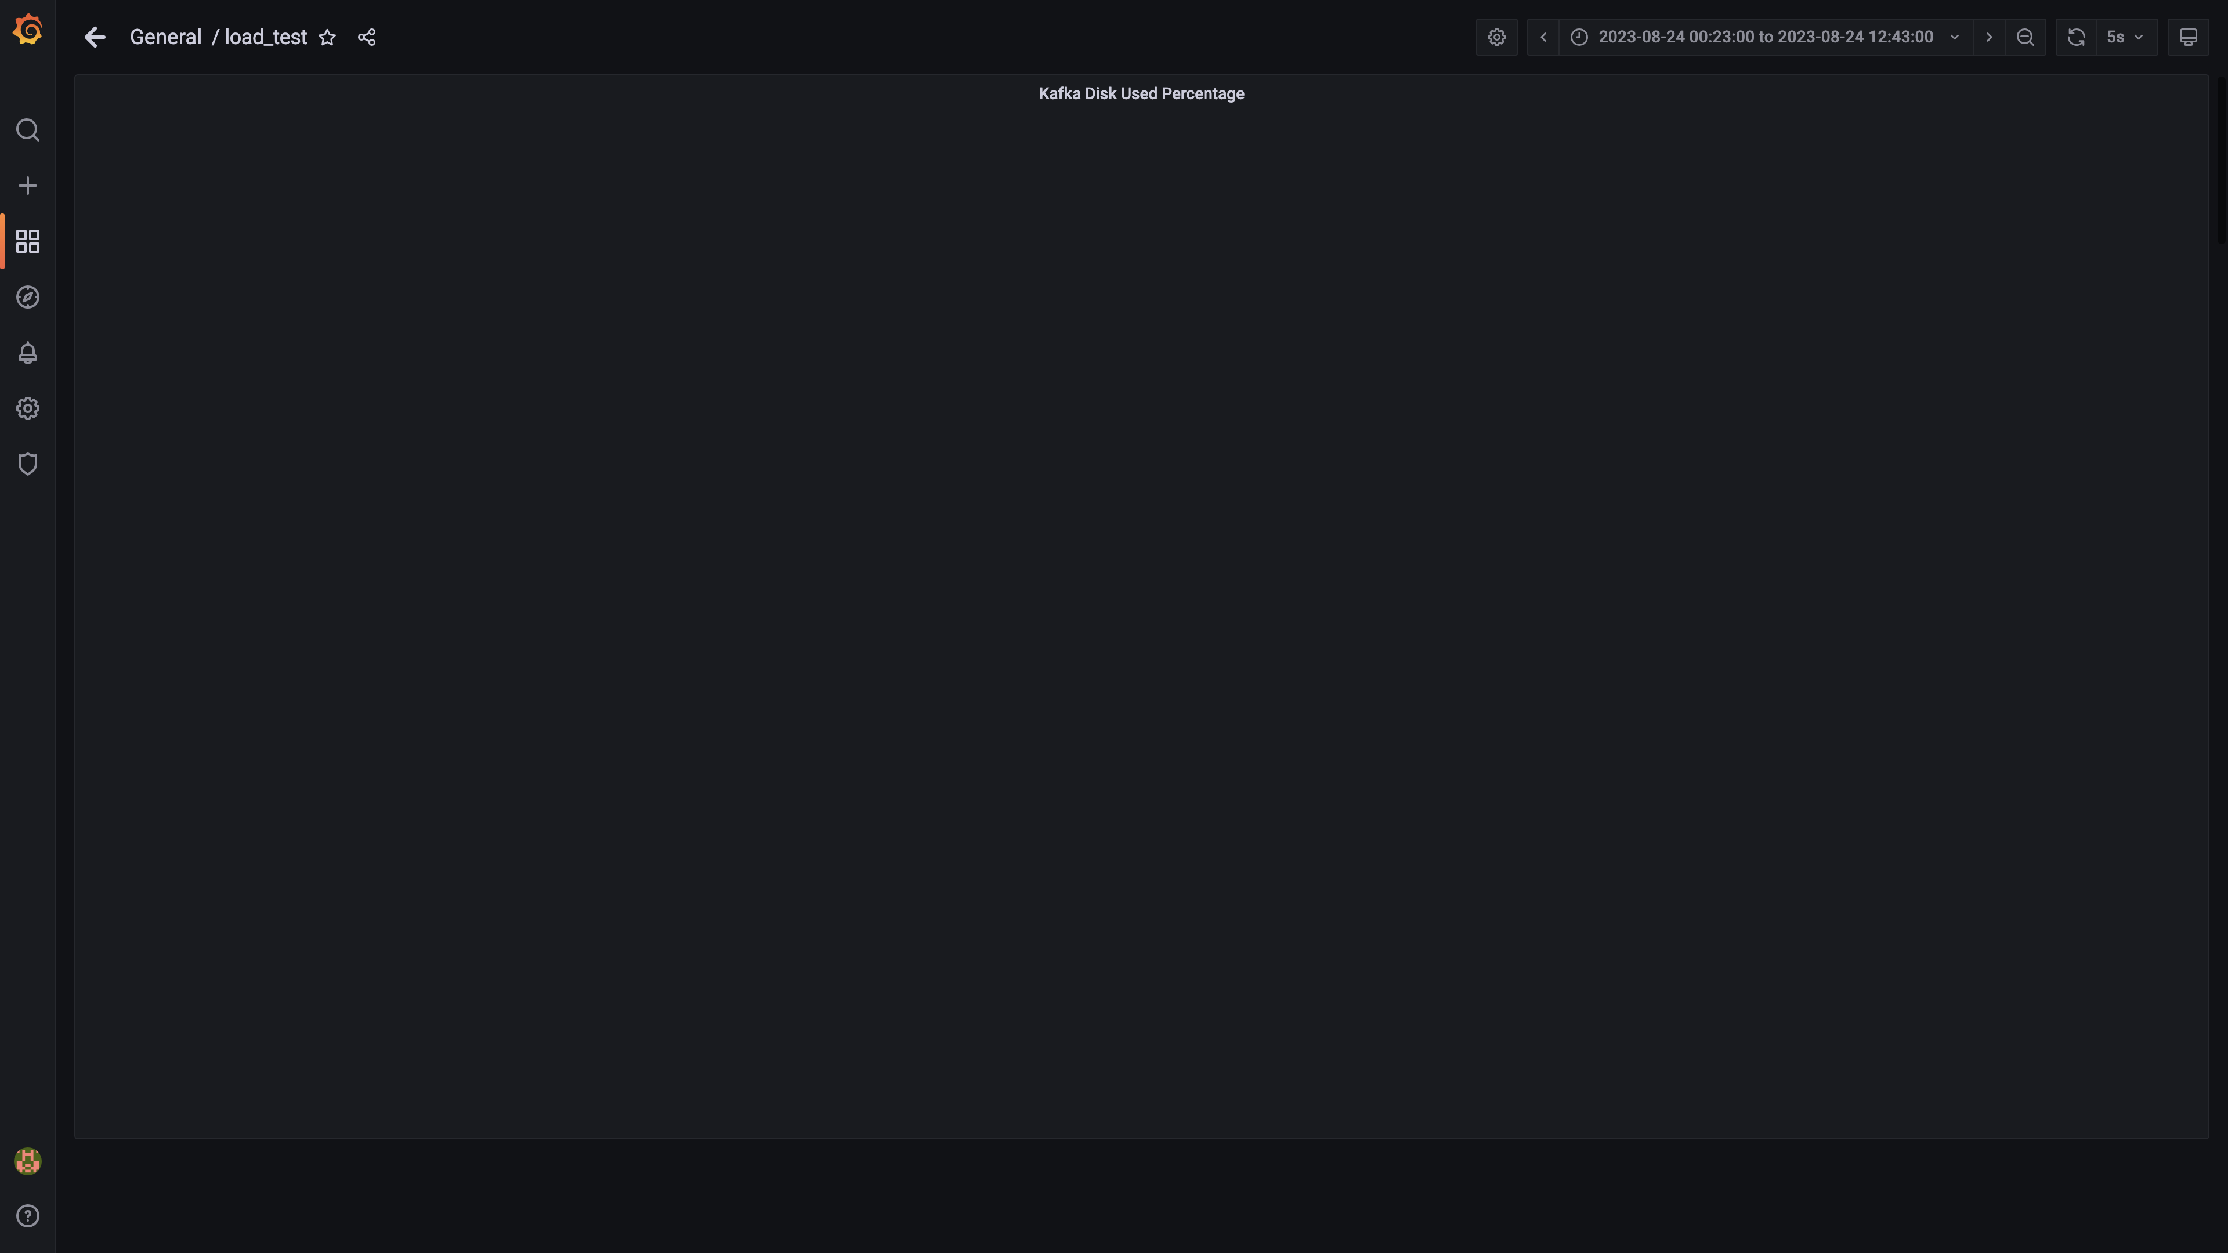

### Top 10 redis client connections by app

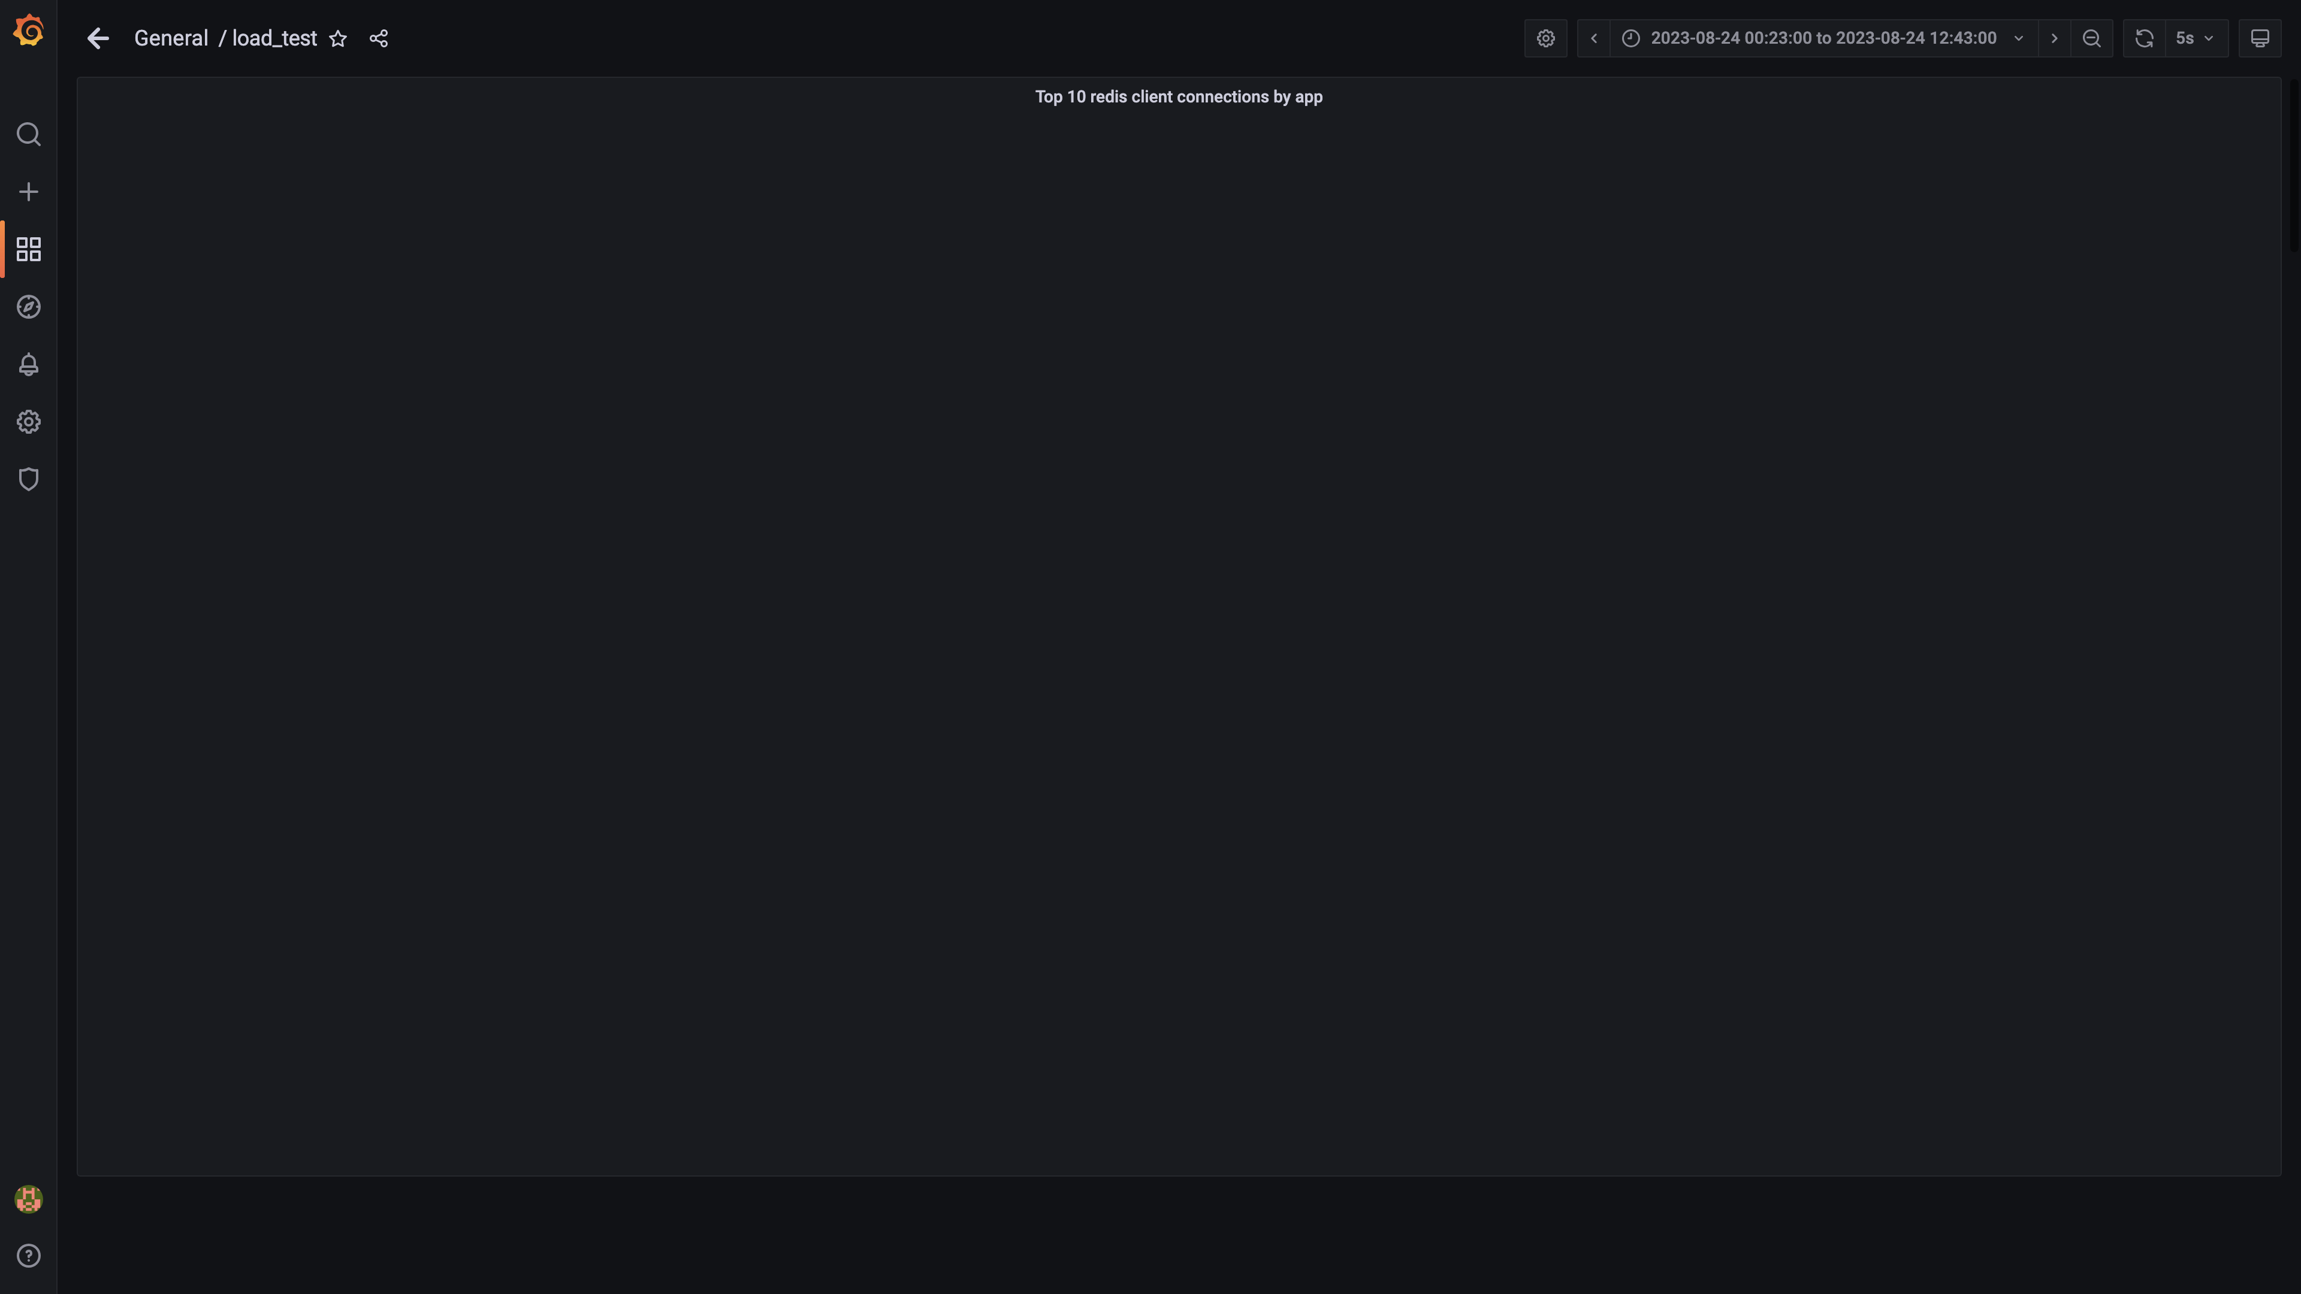

### Compaction status

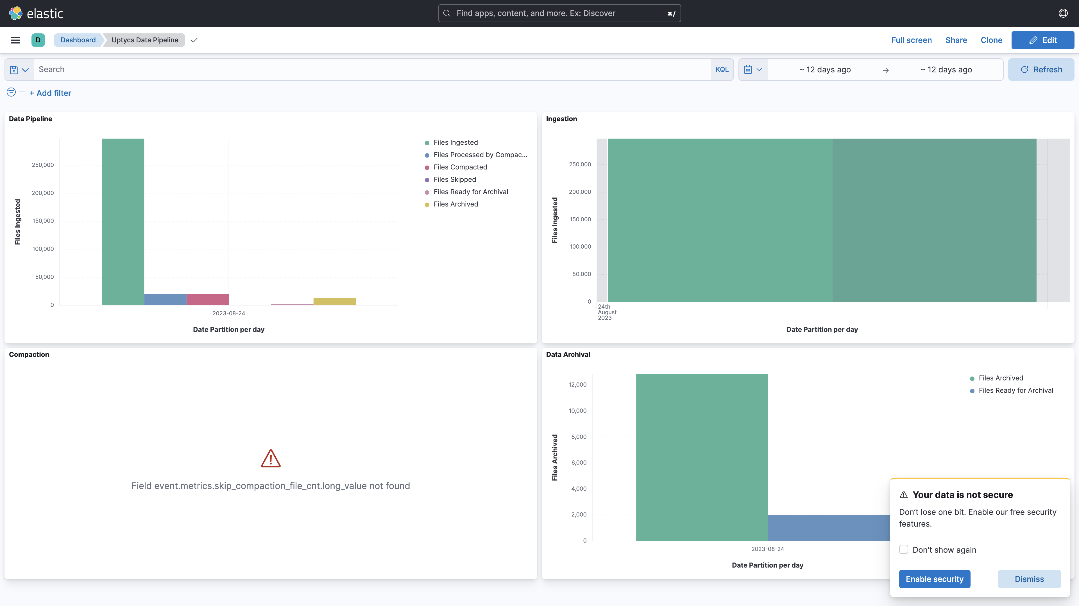

## Average Resource Utilization

### Comparision of Average Memory utilization

|  |  |  |  |  |
| --- | --- | --- | --- | --- |
| Metric | 138005 | 139005 | Absolute(%) | Relative(%) |
| Memory used by mlbank1a | - | 2.58% | - | - |
| Memory used by s4c1dn1 | 67.22% | 67.22% | 0.00% | 0.00% |
| Memory used by s4c1dn2 | 53.42% | 53.42% | 0.00% | 0.00% |
| Memory used by s4c1dn3 | 53.59% | 53.59% | 0.00% | 0.00% |
| Memory used by s4c1dn4 | 48.49% | 48.49% | 0.00% | 0.00% |
| Memory used by s4c1dn5 | 48.85% | 48.85% | 0.00% | 0.00% |
| Memory used by s4c1dn6 | 50.34% | 50.34% | 0.00% | 0.00% |
| Memory used by s4c1pn1 | 30.28% | 30.28% | 0.00% | 0.00% |
| Memory used by s4c1pn2 | 34.00% | 34.00% | 0.00% | 0.00% |
| Memory used by s4c1pn3 | 28.70% | 28.70% | 0.00% | 0.00% |
| Memory used by s4c1pn4 | 27.69% | 27.69% | 0.00% | 0.00% |
| Memory used by s4c1pn5 | 28.21% | 28.21% | 0.00% | 0.00% |
| Memory used by s4c1pn6 | 27.38% | 27.38% | 0.00% | 0.00% |
| Memory used by s4c2dn1 | 59.56% | 59.56% | 0.00% | 0.00% |
| Memory used by s4c2dn2 | 46.09% | 46.09% | 0.00% | 0.00% |
| Memory used by s4c2dn3 | 46.77% | 46.77% | 0.00% | 0.00% |
| Memory used by s4c2dn4 | 45.68% | 45.68% | 0.00% | 0.00% |
| Memory used by s4c2dn5 | 46.93% | 46.93% | 0.00% | 0.00% |
| Memory used by s4c2dn6 | 46.57% | 46.57% | 0.00% | 0.00% |
| Memory used by s4c2pn1 | 25.89% | 25.89% | 0.00% | 0.00% |
| Memory used by s4c2pn2 | 26.93% | 26.93% | 0.00% | 0.00% |
| Memory used by s4c2pn3 | 26.19% | 26.19% | 0.00% | 0.00% |
| Memory used by s4c2pn4 | 27.82% | 27.82% | 0.00% | 0.00% |
| Memory used by s4c2pn5 | 26.51% | 26.51% | 0.00% | 0.00% |
| Memory used by s4c2pn6 | 25.80% | 25.80% | 0.00% | 0.00% |
| Memory used by s4configdb1 | 1.46% | 1.46% | 0.00% | 0.00% |
| Memory used by s4configdb2 | 4.91% | 4.91% | 0.00% | 0.00% |
| Memory used by s4mon | 10.88% | 10.88% | 0.00% | 0.00% |
| Memory used by s4stsnode1 | - | 30.07% | - | - |
| Memory used by s4stsnode2 | - | 25.82% | - | - |
| Memory used by Rule Engine s4c1pn1 | 5.94% | 5.94% | 0.00% | 0.00% |
| Memory used by Rule Engine s4c1pn2 | 5.77% | 5.77% | 0.00% | 0.00% |
| Memory used by Rule Engine s4c1pn3 | 5.66% | 5.66% | 0.00% | 0.00% |
| Memory used by Rule Engine s4c1pn4 | 5.57% | 5.57% | 0.00% | 0.00% |
| Memory used by Rule Engine s4c1pn5 | 5.70% | 5.70% | 0.00% | 0.00% |
| Memory used by Rule Engine s4c1pn6 | 5.57% | 5.57% | 0.00% | 0.00% |
| Memory used by Rule Engine s4c2pn1 | 5.62% | 5.62% | 0.00% | 0.00% |
| Memory used by Rule Engine s4c2pn2 | 5.59% | 5.59% | 0.00% | 0.00% |
| Memory used by Rule Engine s4c2pn3 | 5.50% | 5.50% | 0.00% | 0.00% |
| Memory used by Rule Engine s4c2pn4 | 5.65% | 5.65% | 0.00% | 0.00% |
| Memory used by Rule Engine s4c2pn5 | 5.74% | 5.74% | 0.00% | 0.00% |
| Memory used by Rule Engine s4c2pn6 | 5.62% | 5.62% | 0.00% | 0.00% |
| Memory used by Osquery Ingestion s4c1dn1 | 5.54% | 5.54% | 0.00% | 0.00% |
| Memory used by Osquery Ingestion s4c1dn2 | 5.68% | 5.68% | 0.00% | 0.00% |
| Memory used by Osquery Ingestion s4c1dn3 | 5.61% | 5.61% | 0.00% | 0.00% |
| Memory used by Osquery Ingestion s4c1dn4 | 5.09% | 5.09% | 0.00% | 0.00% |
| Memory used by Osquery Ingestion s4c1dn5 | 4.81% | 4.81% | 0.00% | 0.00% |
| Memory used by Osquery Ingestion s4c1dn6 | 5.27% | 5.27% | 0.00% | 0.00% |
| Memory used by Osquery Ingestion s4c2dn1 | 5.81% | 5.81% | 0.00% | 0.00% |
| Memory used by Osquery Ingestion s4c2dn2 | 5.43% | 5.43% | 0.00% | 0.00% |
| Memory used by Osquery Ingestion s4c2dn3 | 5.87% | 5.87% | 0.00% | 0.00% |
| Memory used by Osquery Ingestion s4c2dn4 | 5.73% | 5.73% | 0.00% | 0.00% |
| Memory used by Osquery Ingestion s4c2dn5 | 5.62% | 5.62% | 0.00% | 0.00% |
| Memory used by Osquery Ingestion s4c2dn6 | 5.83% | 5.83% | 0.00% | 0.00% |
| Memory used by Kafka s4c1pn1 | 2.90% | 2.90% | 0.00% | 0.00% |
| Memory used by Kafka s4c1pn2 | 3.50% | 3.50% | 0.00% | 0.00% |
| Memory used by Kafka s4c1pn3 | 3.45% | 3.45% | 0.00% | 0.00% |
| Memory used by Kafka s4c1pn4 | 3.50% | 3.50% | 0.00% | 0.00% |
| Memory used by Kafka s4c1pn5 | 3.50% | 3.50% | 0.00% | 0.00% |
| Memory used by Kafka s4c1pn6 | 3.50% | 3.50% | 0.00% | 0.00% |
| Memory used by Kafka s4c2pn1 | 2.88% | 2.88% | 0.00% | 0.00% |
| Memory used by Kafka s4c2pn2 | 3.49% | 3.49% | 0.00% | 0.00% |
| Memory used by Kafka s4c2pn3 | 3.40% | 3.40% | 0.00% | 0.00% |
| Memory used by Kafka s4c2pn4 | 3.47% | 3.47% | 0.00% | 0.00% |
| Memory used by Kafka s4c2pn5 | 3.50% | 3.50% | 0.00% | 0.00% |
| Memory used by Kafka s4c2pn6 | 3.50% | 3.50% | 0.00% | 0.00% |
| Memory used by Trino s4c1dn1 | 16.23% | 16.23% | 0.00% | 0.00% |
| Memory used by Trino s4c1dn2 | 16.88% | 16.88% | 0.00% | 0.00% |
| Memory used by Trino s4c1dn3 | 16.75% | 16.75% | 0.00% | 0.00% |
| Memory used by Trino s4c1dn4 | 16.77% | 16.77% | 0.00% | 0.00% |
| Memory used by Trino s4c1dn5 | 16.86% | 16.86% | 0.00% | 0.00% |
| Memory used by Trino s4c1dn6 | 16.84% | 16.84% | 0.00% | 0.00% |
| Memory used by Trino s4c2dn1 | 24.18% | 24.18% | 0.00% | 0.00% |
| Memory used by Trino s4c2dn2 | 16.54% | 16.54% | 0.00% | 0.00% |
| Memory used by Trino s4c2dn3 | 16.63% | 16.63% | 0.00% | 0.00% |
| Memory used by Trino s4c2dn4 | 16.46% | 16.46% | 0.00% | 0.00% |
| Memory used by Trino s4c2dn5 | 16.56% | 16.56% | 0.00% | 0.00% |
| Memory used by Trino s4c2dn6 | 16.44% | 16.44% | 0.00% | 0.00% |
| Memory used by Tls s4c1pn1 | 0.20% | 0.20% | 0.00% | 0.00% |
| Memory used by Tls s4c1pn2 | 0.20% | 0.20% | 0.00% | 0.00% |
| Memory used by Tls s4c1pn3 | 0.20% | 0.20% | 0.00% | 0.00% |
| Memory used by Tls s4c1pn4 | 0.20% | 0.20% | 0.00% | 0.00% |
| Memory used by Tls s4c1pn5 | 0.20% | 0.20% | 0.00% | 0.00% |
| Memory used by Tls s4c1pn6 | 0.20% | 0.20% | 0.00% | 0.00% |
| Memory used by Tls s4c2pn1 | 0.20% | 0.20% | 0.00% | 0.00% |
| Memory used by Tls s4c2pn2 | 0.20% | 0.20% | 0.00% | 0.00% |
| Memory used by Tls s4c2pn3 | 0.20% | 0.20% | 0.00% | 0.00% |
| Memory used by Tls s4c2pn4 | 0.20% | 0.20% | 0.00% | 0.00% |
| Memory used by Tls s4c2pn5 | 0.20% | 0.20% | 0.00% | 0.00% |
| Memory used by Tls s4c2pn6 | 0.20% | 0.20% | 0.00% | 0.00% |
| Memory used by EventsDbIngestion s4c1dn1 | 0.69% | 0.69% | 0.00% | 0.00% |
| Memory used by EventsDbIngestion s4c1dn2 | 1.03% | 1.03% | 0.00% | 0.00% |
| Memory used by EventsDbIngestion s4c1dn3 | 1.04% | 1.04% | 0.00% | 0.00% |
| Memory used by EventsDbIngestion s4c1dn4 | 1.04% | 1.04% | 0.00% | 0.00% |
| Memory used by EventsDbIngestion s4c1dn5 | 0.98% | 0.98% | 0.00% | 0.00% |
| Memory used by EventsDbIngestion s4c1dn6 | 1.02% | 1.02% | 0.00% | 0.00% |
| Memory used by EventsDbIngestion s4c2dn1 | 0.69% | 0.69% | 0.00% | 0.00% |
| Memory used by EventsDbIngestion s4c2dn2 | 0.98% | 0.98% | 0.00% | 0.00% |
| Memory used by EventsDbIngestion s4c2dn3 | 1.01% | 1.01% | 0.00% | 0.00% |
| Memory used by EventsDbIngestion s4c2dn4 | 1.03% | 1.03% | 0.00% | 0.00% |
| Memory used by EventsDbIngestion s4c2dn5 | 1.06% | 1.06% | 0.00% | 0.00% |
| Memory used by EventsDbIngestion s4c2dn6 | 1.02% | 1.02% | 0.00% | 0.00% |
| Memory used by Logger s4c1pn1 | 0.85% | 0.85% | 0.00% | 0.00% |
| Memory used by Logger s4c1pn2 | 0.67% | 0.67% | 0.00% | 0.00% |
| Memory used by Logger s4c1pn3 | 0.73% | 0.73% | 0.00% | 0.00% |
| Memory used by Logger s4c1pn4 | 0.80% | 0.80% | 0.00% | 0.00% |
| Memory used by Logger s4c1pn5 | 0.81% | 0.81% | 0.00% | 0.00% |
| Memory used by Logger s4c1pn6 | 1.21% | 1.21% | 0.00% | 0.00% |
| Memory used by Logger s4c2pn1 | 0.93% | 0.93% | 0.00% | 0.00% |
| Memory used by Logger s4c2pn2 | 1.20% | 1.20% | 0.00% | 0.00% |
| Memory used by Logger s4c2pn3 | 1.16% | 1.16% | 0.00% | 0.00% |
| Memory used by Logger s4c2pn4 | 1.26% | 1.26% | 0.00% | 0.00% |
| Memory used by Logger s4c2pn5 | 1.05% | 1.05% | 0.00% | 0.00% |
| Memory used by Logger s4c2pn6 | 1.10% | 1.10% | 0.00% | 0.00% |

### Comparision of Average CPU utilization

|  |  |  |  |  |
| --- | --- | --- | --- | --- |
| Metric | 138005 | 139005 | Absolute(%) | Relative(%) |
| CPU used by mlbank1a | - | 93.03% | - | - |
| CPU used by s4c1dn1 | 16.79% | 16.79% | 0.00% | 0.00% |
| CPU used by s4c1dn2 | 14.35% | 14.35% | 0.00% | 0.00% |
| CPU used by s4c1dn3 | 14.91% | 14.91% | 0.00% | 0.00% |
| CPU used by s4c1dn4 | 12.28% | 12.28% | 0.00% | 0.00% |
| CPU used by s4c1dn5 | 12.59% | 12.59% | 0.00% | 0.00% |
| CPU used by s4c1dn6 | 13.50% | 13.50% | 0.00% | 0.00% |
| CPU used by s4c1pn1 | 33.36% | 33.36% | 0.00% | 0.00% |
| CPU used by s4c1pn2 | 30.15% | 30.15% | 0.00% | 0.00% |
| CPU used by s4c1pn3 | 29.45% | 29.45% | 0.00% | 0.00% |
| CPU used by s4c1pn4 | 27.11% | 27.11% | 0.00% | 0.00% |
| CPU used by s4c1pn5 | 28.23% | 28.23% | 0.00% | 0.00% |
| CPU used by s4c1pn6 | 26.81% | 26.81% | 0.00% | 0.00% |
| CPU used by s4c2dn1 | 15.09% | 15.09% | 0.00% | 0.00% |
| CPU used by s4c2dn2 | 13.48% | 13.48% | 0.00% | 0.00% |
| CPU used by s4c2dn3 | 11.58% | 11.58% | 0.00% | 0.00% |
| CPU used by s4c2dn4 | 12.06% | 12.06% | 0.00% | 0.00% |
| CPU used by s4c2dn5 | 12.10% | 12.10% | 0.00% | 0.00% |
| CPU used by s4c2dn6 | 12.43% | 12.43% | 0.00% | 0.00% |
| CPU used by s4c2pn1 | 30.51% | 30.51% | 0.00% | 0.00% |
| CPU used by s4c2pn2 | 26.94% | 26.94% | 0.00% | 0.00% |
| CPU used by s4c2pn3 | 26.41% | 26.41% | 0.00% | 0.00% |
| CPU used by s4c2pn4 | 25.76% | 25.76% | 0.00% | 0.00% |
| CPU used by s4c2pn5 | 26.64% | 26.64% | 0.00% | 0.00% |
| CPU used by s4c2pn6 | 27.75% | 27.75% | 0.00% | 0.00% |
| CPU used by s4configdb1 | 1.80% | 1.80% | 0.00% | 0.00% |
| CPU used by s4configdb2 | 62.74% | 62.74% | 0.00% | 0.00% |
| CPU used by s4mon | 5.54% | 5.54% | 0.00% | 0.00% |
| CPU used by s4stsnode1 | - | 13.49% | - | - |
| CPU used by s4stsnode2 | - | 11.37% | - | - |
| CPU used by Rule Engine s4c1pn1 | 316.94% | 316.94% | 0.00% | 0.00% |
| CPU used by Rule Engine s4c1pn2 | 306.54% | 306.54% | 0.00% | 0.00% |
| CPU used by Rule Engine s4c1pn3 | 319.72% | 319.72% | 0.00% | 0.00% |
| CPU used by Rule Engine s4c1pn4 | 301.09% | 301.09% | 0.00% | 0.00% |
| CPU used by Rule Engine s4c1pn5 | 313.73% | 313.73% | 0.00% | 0.00% |
| CPU used by Rule Engine s4c1pn6 | 306.07% | 306.07% | 0.00% | 0.00% |
| CPU used by Rule Engine s4c2pn1 | 316.39% | 316.39% | 0.00% | 0.00% |
| CPU used by Rule Engine s4c2pn2 | 302.48% | 302.48% | 0.00% | 0.00% |
| CPU used by Rule Engine s4c2pn3 | 294.86% | 294.86% | 0.00% | 0.00% |
| CPU used by Rule Engine s4c2pn4 | 307.32% | 307.32% | 0.00% | 0.00% |
| CPU used by Rule Engine s4c2pn5 | 291.71% | 291.71% | 0.00% | 0.00% |
| CPU used by Rule Engine s4c2pn6 | 306.39% | 306.39% | 0.00% | 0.00% |
| CPU used by Osquery Ingestion s4c1dn1 | 17.70% | 17.70% | 0.00% | 0.00% |
| CPU used by Osquery Ingestion s4c1dn2 | 28.30% | 28.30% | 0.00% | 0.00% |
| CPU used by Osquery Ingestion s4c1dn3 | 32.31% | 32.31% | 0.00% | 0.00% |
| CPU used by Osquery Ingestion s4c1dn4 | 27.30% | 27.30% | 0.00% | 0.00% |
| CPU used by Osquery Ingestion s4c1dn5 | 27.71% | 27.71% | 0.00% | 0.00% |
| CPU used by Osquery Ingestion s4c1dn6 | 36.66% | 36.66% | 0.00% | 0.00% |
| CPU used by Osquery Ingestion s4c2dn1 | 22.90% | 22.90% | 0.00% | 0.00% |
| CPU used by Osquery Ingestion s4c2dn2 | 34.77% | 34.77% | 0.00% | 0.00% |
| CPU used by Osquery Ingestion s4c2dn3 | 25.92% | 25.92% | 0.00% | 0.00% |
| CPU used by Osquery Ingestion s4c2dn4 | 32.16% | 32.16% | 0.00% | 0.00% |
| CPU used by Osquery Ingestion s4c2dn5 | 30.12% | 30.12% | 0.00% | 0.00% |
| CPU used by Osquery Ingestion s4c2dn6 | 37.94% | 37.94% | 0.00% | 0.00% |
| CPU used by Kafka s4c1pn1 | 83.14% | 83.14% | 0.00% | 0.00% |
| CPU used by Kafka s4c1pn2 | 46.07% | 46.07% | 0.00% | 0.00% |
| CPU used by Kafka s4c1pn3 | 78.06% | 78.06% | 0.00% | 0.00% |
| CPU used by Kafka s4c1pn4 | 45.17% | 45.17% | 0.00% | 0.00% |
| CPU used by Kafka s4c1pn5 | 78.59% | 78.59% | 0.00% | 0.00% |
| CPU used by Kafka s4c1pn6 | 52.52% | 52.52% | 0.00% | 0.00% |
| CPU used by Kafka s4c2pn1 | 61.34% | 61.34% | 0.00% | 0.00% |
| CPU used by Kafka s4c2pn2 | 65.19% | 65.19% | 0.00% | 0.00% |
| CPU used by Kafka s4c2pn3 | 62.70% | 62.70% | 0.00% | 0.00% |
| CPU used by Kafka s4c2pn4 | 63.50% | 63.50% | 0.00% | 0.00% |
| CPU used by Kafka s4c2pn5 | 61.66% | 61.66% | 0.00% | 0.00% |
| CPU used by Kafka s4c2pn6 | 63.01% | 63.01% | 0.00% | 0.00% |
| CPU used by Trino s4c1dn1 | 9.87% | 9.87% | 0.00% | 0.00% |
| CPU used by Trino s4c1dn2 | 16.21% | 16.21% | 0.00% | 0.00% |
| CPU used by Trino s4c1dn3 | 17.20% | 17.20% | 0.00% | 0.00% |
| CPU used by Trino s4c1dn4 | 13.99% | 13.99% | 0.00% | 0.00% |
| CPU used by Trino s4c1dn5 | 13.49% | 13.49% | 0.00% | 0.00% |
| CPU used by Trino s4c1dn6 | 13.63% | 13.63% | 0.00% | 0.00% |
| CPU used by Trino s4c2dn1 | 14.69% | 14.69% | 0.00% | 0.00% |
| CPU used by Trino s4c2dn2 | 11.45% | 11.45% | 0.00% | 0.00% |
| CPU used by Trino s4c2dn3 | 11.51% | 11.51% | 0.00% | 0.00% |
| CPU used by Trino s4c2dn4 | 12.90% | 12.90% | 0.00% | 0.00% |
| CPU used by Trino s4c2dn5 | 9.95% | 9.95% | 0.00% | 0.00% |
| CPU used by Trino s4c2dn6 | 9.40% | 9.40% | 0.00% | 0.00% |
| CPU used by Tls s4c1pn1 | 9.40% | 9.40% | 0.00% | 0.00% |
| CPU used by Tls s4c1pn2 | 9.51% | 9.51% | 0.00% | 0.00% |
| CPU used by Tls s4c1pn3 | 8.14% | 8.14% | 0.00% | 0.00% |
| CPU used by Tls s4c1pn4 | 7.67% | 7.67% | 0.00% | 0.00% |
| CPU used by Tls s4c1pn5 | 8.05% | 8.05% | 0.00% | 0.00% |
| CPU used by Tls s4c1pn6 | 8.61% | 8.61% | 0.00% | 0.00% |
| CPU used by Tls s4c2pn1 | 9.35% | 9.35% | 0.00% | 0.00% |
| CPU used by Tls s4c2pn2 | 7.63% | 7.63% | 0.00% | 0.00% |
| CPU used by Tls s4c2pn3 | 6.08% | 6.08% | 0.00% | 0.00% |
| CPU used by Tls s4c2pn4 | 6.02% | 6.02% | 0.00% | 0.00% |
| CPU used by Tls s4c2pn5 | 7.02% | 7.02% | 0.00% | 0.00% |
| CPU used by Tls s4c2pn6 | 10.14% | 10.14% | 0.00% | 0.00% |
| CPU used by EventsDbIngestion s4c1dn1 | 4.27% | 4.27% | 0.00% | 0.00% |
| CPU used by EventsDbIngestion s4c1dn2 | 5.45% | 5.45% | 0.00% | 0.00% |
| CPU used by EventsDbIngestion s4c1dn3 | 8.63% | 8.63% | 0.00% | 0.00% |
| CPU used by EventsDbIngestion s4c1dn4 | 5.29% | 5.29% | 0.00% | 0.00% |
| CPU used by EventsDbIngestion s4c1dn5 | 5.66% | 5.66% | 0.00% | 0.00% |
| CPU used by EventsDbIngestion s4c1dn6 | 5.97% | 5.97% | 0.00% | 0.00% |
| CPU used by EventsDbIngestion s4c2dn1 | 4.57% | 4.57% | 0.00% | 0.00% |
| CPU used by EventsDbIngestion s4c2dn2 | 5.38% | 5.38% | 0.00% | 0.00% |
| CPU used by EventsDbIngestion s4c2dn3 | 6.01% | 6.01% | 0.00% | 0.00% |
| CPU used by EventsDbIngestion s4c2dn4 | 6.59% | 6.59% | 0.00% | 0.00% |
| CPU used by EventsDbIngestion s4c2dn5 | 7.95% | 7.95% | 0.00% | 0.00% |
| CPU used by EventsDbIngestion s4c2dn6 | 5.65% | 5.65% | 0.00% | 0.00% |
| CPU used by Logger s4c1pn1 | 34.98% | 34.98% | 0.00% | 0.00% |
| CPU used by Logger s4c1pn2 | 31.65% | 31.65% | 0.00% | 0.00% |
| CPU used by Logger s4c1pn3 | 33.41% | 33.41% | 0.00% | 0.00% |
| CPU used by Logger s4c1pn4 | 31.88% | 31.88% | 0.00% | 0.00% |
| CPU used by Logger s4c1pn5 | 34.34% | 34.34% | 0.00% | 0.00% |
| CPU used by Logger s4c1pn6 | 37.50% | 37.50% | 0.00% | 0.00% |
| CPU used by Logger s4c2pn1 | 33.64% | 33.64% | 0.00% | 0.00% |
| CPU used by Logger s4c2pn2 | 35.92% | 35.92% | 0.00% | 0.00% |
| CPU used by Logger s4c2pn3 | 36.73% | 36.73% | 0.00% | 0.00% |
| CPU used by Logger s4c2pn4 | 36.42% | 36.42% | 0.00% | 0.00% |
| CPU used by Logger s4c2pn5 | 35.15% | 35.15% | 0.00% | 0.00% |
| CPU used by Logger s4c2pn6 | 36.62% | 36.62% | 0.00% | 0.00% |

## Overall Usages

### Comparision of Overall Memory utilization

|  |  |  |  |
| --- | --- | --- | --- |
| Metric | 138005 | 139005 | Delta |
| Average Memory used by pnodes | 630.56 GB | 630.56 GB | 0.00% (0.00 GB) |
| Average Memory used by dnodes | 1539.90 GB | 1539.90 GB | 0.00% (0.00 GB) |
| Average Memory used by pgnodes | 11.96 GB | 11.96 GB | 0.00% (0.00 GB) |

### Comparision of Overall CPU utilization

|  |  |  |  |
| --- | --- | --- | --- |
| Metric | 138005 | 139005 | Delta |
| Average CPU used by pnodes | 108.52 cores | 108.52 cores | 0.00% (0.00 cores) |
| Average CPU used by dnodes | 51.57 cores | 51.57 cores | 0.00% (0.00 cores) |
| Average CPU used by pgnodes | 20.66 cores | 20.66 cores | 0.00% (0.00 cores) |